**The following describes the levels of approval required for all plans and amendments.**

1. For PMEL, Collen Marquist is first to review the plan. For AFSC and NWFSC, Burlyn Birkemeier is first to review the plan. Initials are required from one College Health and Safety Committee member (Birkemeier and Marquist) before the PI can sign.
2. The supervisor of the employee submitting the plan adds their revisions.
3. When all revisions have been addressed, the project PI signs the plan or amendment and emails the Google link to John Horne ([jhorne@uw.edu](mailto:jhorne@uw.edu)) and Collen Marquist ([marquist@uw.edu](mailto:marquist@uw.edu)).
4. John Horne will point out necessary comments or revisions. Once they have all been addressed, John will download the plan as a PDF, sign it, and email the final version to the PI, field scientist, and Collen Marquist.

| **CICOES** | **Cooperative Institute for Climate, Ocean & Ecosystem Studies** | | |
| --- | --- | --- | --- |
| **Plan Created for** | College of the Environment, CICOES, NOAA PMEL EcoFOCI and ‘Omics and NOAA AFSC Marine Mammal Laboratory | **Date of revision:** | 03/14/2023 |
| **CICOES PI/Supervisor** | Calvin Mordy - [calvin.w.mordy@noaa.gov](mailto:calvin.w.mordy@noaa.gov) | **Budget Number:** EcoFOCI (Task II FOCI 62-3584), Omics (Task II Genomics 62-3574), MML (Task II Acoustics 62-3457) | |
| **Field Team Leader/ Chief Scientist and Names of Participants** | **Chief Scientist**: Shaun Bell - [shaun.bell@noaa.gov](mailto:shaun.bell@noaa.gov) (405-326-4283)  David Strausz - [david.strausz@noaa.gov](mailto:david.strausz@noaa.gov) (509-830-7445) - EcoFOCI  Peter Proctor - [Peter.Proctor@noaa.gov](mailto:Peter.Proctor@noaa.gov) (206 604 8638) - EcoFOCI  Brynn Kimber - [brynn.kimber@noaa.gov](mailto:brynn.kimber@noaa.gov) (360-739-9554) - MML  Shannon Brown - [shannon.brown@noaa.gov](mailto:shannon.brown@noaa.gov) (847-445-2292) - OMICS | | |
| **Activity Description** | The purpose of the spring mooring cruise is to turn around various FOCI and MML moorings located in the Bering Sea and perform CTD/Bongo surveys at long-term EcoFOCI moored sites. | | |
| **Field Site Location(s)** | Field sites are located in the Gulf of Alaska and Bering Sea (see Appendix 1). The vessel will depart from Kodiak, AK and return to Dutch Harbor, AK. | | |
| **Date(s) of Fieldwork** | Travel dates: 18 April - 8 May 2023  Cruise dates: 21 April - 7 May 2023 | | |

**Preliminary review conducted by: _BB and CM_____ Initials of Health and Safety Representative: ___BB__**

| **Approved by:** | *John Horne, Director CICOES* | *03/22/2023* |
| --- | --- | --- |

**Adherence to University policy and a professional code of conduct by all members of a project field team while participating in University-sponsored fieldwork is required.**

# 

# 

# Signature of PI/Supervisor:

I approve this safety plan and acknowledge that it has been prepared for fieldwork under my supervision.

| **Name** | **Signature** | **Date** | **Phone Number** |
| --- | --- | --- | --- |
| Calvin Mordy - [calvin.w.mordy@noaa.gov](mailto:calvin.w.mordy@noaa.gov) |  | **3/14/2023** | 206-535-4321 |

**Field Team/Participant Roster - Training Documentation1**

**I understand that this Project Health and Safety Plan is intended to document hazard assessments, communication plans, emergency procedures, and training requirements for the proposed fieldwork. This plan also identifies hazards, as well as precautions and actions to be taken to address and mitigate those hazards, to significantly mitigate the risk of COVID-19 exposure and transmission, but is not a substitute for self-isolation for individuals who may have concerns about their health or that of others. I verify that I have read this Fieldwork Health and Safety Plan, understand its contents, am voluntarily participating in the fieldwork, and agree to comply with its requirements.**

| **Name/Email/Cell Phone #** | **Signature** | **Date** | **First Aid Training Completed\*** |
| --- | --- | --- | --- |
| David Strausz [david.strausz@noaa.gov](mailto:david.strausz@noaa.gov)  (509-830-7445) |  | 03/14/2023 | Adult, Child and Baby First Aid/CPR/AED Online - Completed 12/2021 |
| Peter Proctor [Peter.Proctor@noaa.gov](mailto:Peter.Proctor@noaa.gov)  (206 604 8638) | [Peter d' Proctor](mailto:peterdurphee@gmail.com) | 03/14/2023 | Adult, Child and Baby First Aid/CPR/AED Online - Completed 07/2022 |
| Brynn Kimber [brynn.kimber@noaa.gov](mailto:brynn.kimber@noaa.gov)  (360-739-9554) |  | 03/14/2023 | Adult First Aid - Completed 1/2022 |
| Shannon Brown [shannon.brown@noaa.gov](mailto:shannon.brown@noaa.gov) (847-445-2292) |  | 03/14/2023 | Adult First Aid/CPR/AED Online Only- Completed 6/2021 |

**1All research field teams must include at least one individual with valid first aid certification.**

| Site Information | |
| --- | --- |
| **Location(s)** | 4/18/2023 - Arrive in Kodiak, AK  4/19-20/2023 - In-Port COVID Testing; Load Ship  4/21/2023 - Depart from Kodiak on Oscar Dyson to Bering Sea  4/22/2023-5/6/2023 - Conduct mooring, CTD, and bongo net operations (see Appendix 1)  5/7/2023 - Arrive in Dutch Harbor, AK  5/8/2023 - Return to Seattle |
| **Site Information** | Work will be conducted on board the NOAA ship, Oscar Dyson. A majority of the work will be outdoors on the back deck and on the side deck for the CTD and bongo nets. The CTD will be run from the electronics lab, and all samples will be processed in the chem or wet lab.  Weather conditions in the Bering can be unpredictable and cold. Safety meetings will be held before each mooring operation to review safety issues and discuss weather options, if applicable. Steel toe boots are required on deck along with mustang float coats and hardhats. Waterproof insulated gloves are provided for working on deck as it is anticipated that working conditions will occur during freezing temperature. |
| **Travel to Site** | All CICOES participants will travel to Kodiak, AK and from Dutch Harbor, AK via commercial airline. In both localities, rental cars will be used to transit between the airport, hotel, stores, and dock. In accordance with Marine Operation Guidelines, all personnel are required to take a COVID test within 24 hours of departure. |
| **Ownership** | NOAA Ship *Oscar Dyson*  Marine Operations Center-Pacific  2002 SE Marine Science Dr.  Newport, OR 97365  [Noaa.Ship.Oscar.Dyson@noaa.gov](mailto:Noaa.Ship.Oscar.Dyson@noaa.gov) |
| **Access** | *Are there any particular restrictions or challenges to accessing site? Are collecting or camping permits required? Note any alternate routes or suggested parking areas; gate access codes, etc.* *Make special note if isolated or remote:*  No  Is/are your site(s) open to the public, or do you have written confirmation of your ability to access the site?   | ☐ | Open to the public | ⌧ | Written confirmation of access | ☐ | N/A | | --- | --- | --- | --- | --- | --- | |
| **Security** | Personal safety risks and conduct expectations during both work and free time should be considered and discussed in advance (e.g., alcohol or drug use, leaving the group, situational awareness, sexual harassment, and local crime/security concerns). Review expectations and set the tone for a safe, successful trip. In addition, describe any current travel alerts or restrictions. Note intended mitigation measures; discuss with the field team prior to the trip.   | ⌧ | There are currently no relevant travel measures or restrictions for the location of this work | | --- | --- | | ⌧ | All participants are informed and aware of conduct expectations, which will be discussed prior to the start of work. | | ⌧ | All participants are aware of the personal safety risks involved in this project. They have received proper training and have sufficient experience to complete this type of work. | | ⌧ | All relevant work and conduct protocols, manuals, or information has been distributed, understood, and will be discussed prior to the trip. |   *Please list any other security measures, if applicable*:  Boarding procedures during the loading of the Oscar Dyson include checking in with the watch on the bridge and showing proper ID. The OSI facility is a marine loading facility and as such TWIC or CAC cards are required to enter the property. There are no current travel alerts or restrictions for either ports. |
| **Team Safety** | All members of the UW community have the right to a non-harassing (both sexual and non-sexual in nature) and non-discriminatory environment both on campus and in fieldwork situations. Individuals are encouraged to bring up safety and well-being concerns for themselves or others with the following individuals:  **Field Team**   * Field Team Leader/Chief Scientist: Shaun Bell * Another senior person (e.g., Co-PI, ship captain, bosun): CDR Benjamin LaCour * Other members of the science team: Brynn Kimber * On-site anonymous reporting mechanism: *Describe process, if applicable*   Campus resources can be found in the Reference Information section. |
| **No Go Criteria** | Conditions under which approach to - or activities at - the site will be stopped or canceled.     | ☐ | A confirmed or suspected case of COVID-19 by any personnel involved would stop or cancel operations. | | --- | --- | | ⌧ | Each participant understands that they have the ability to end their participation if they are concerned with any aspect of field operations, feel uncomfortable, or if they are unable to perform their duties safely for any reason. | | ⌧ | Work will not be conducted in unsafe weather conditions. If weather (high winds, low visibility, heavy rains, snow, etc.) will impact the safety of the participants, work will be delayed until it is safe to proceed. | | ⌧ | The decision to conduct work in safe conditions will be discussed by all team members, and ultimately is the responsibility of Shaun Bell to decide if it is safe to proceed. |   *List any other applicable conditions or situations that may stop or cancel field operations:*  All mooring operations will be preceded with a safety meeting to ascertain safe working conditions. Work on the back deck of the ship will be weather dependent. If waves exceed ~10 feet then mooring operations will be delayed until conditions improve. CTD and Bongo stations will be discussed between the bridge and the chief scientist when weather conditions deteriorate to a questionable level.  All participants will be required to test for COVID before departure. A positive test or known contact with a person known to have COVID will remove that person from the cruise. During the cruise, if a person is suspected of having COVID symptoms, the person will be isolated and the ship will return immediately to the nearest port. |
| **Environmental**  **Hazards** | *Describe any dangerous wildlife, insects, endemic diseases, poisonous plants, etc. that participants may encounter. Note intended mitigation measures; discuss prior to trip.*  None |
| **Expected Weather** | The Captain will take into account the weather conditions before departing Dutch Harbor. During the spring mooring cruise, it is expected that the Dyson will encounter snow and or heavy rain. Appropriate working attire will be furnished before the cruise to each participant (no sharing) and they will be reminded of the need to stay dry and to ‘layer up’. It is also expected that at some point the ship will be required to ‘hide’ from bad weather. The Captain in consultation with the chief scientist will make the decision when and where to seek refuge. |
| **Drinking Water Availability** | | ⌧ | Plumbed water available | ☐ | Water cooler with ice provided | ☐ | Bottled water provided | | --- | --- | --- | --- | --- | --- | | ☐ | Natural source and treatment methods (e.g. filtration, boiling, chemical disinfection): | | | | | |
| **Access to Shade/Shelter** | If forecast temperatures exceed 80°F, shade must be provided by natural or artificial means for rest breaks. What will be available to the field team members?   | ⌧ | Building structures | ☐ | Trees | ⌧ | Temporary Canopy/Tarp | ☐ | Vehicle with A/C | | --- | --- | --- | --- | --- | --- | --- | --- |  | ⌧ | Other: temperature will not reach these levels in Alaska | | --- | --- | |
| **High Heat Procedures** | Required when temperatures are expected to exceed 95° F: If possible, limit strenuous tasks to morning or late afternoon hours. Rest breaks in shade must be provided at least 10 minutes every 2 hours (or more if needed). Effective means of communication, observation and monitoring for signs of heat illness are required at all times. Pre-work safety discussion required.   | ☐ | Direct supervision | ☐ | Buddy system | ☐ | Reliable cell or radio contact | | --- | --- | --- | --- | --- | --- |  | ⌧ | Other: temperature will not reach these levels in Alaska | | --- | --- | |
| **Cold Weather Procedures** | Required when temperatures drop below normal and wind speed increases, allowing heat to leave a body more rapidly: If possible, schedule heavy work during the warmer part of the day. Provide frequent breaks in warm areas. Acclimatize new workers and those returning after time away from work. Effective means of communication, observation and monitoring for signs of cold stress are required at all times. Pre-work safety discussion required.   | ⌧ | Direct supervision | ⌧ | Buddy system | ⌧ | Reliable cell or radio contact | | --- | --- | --- | --- | --- | --- | | ☐ | Other:___________________________________________________________ | | | | | |

| Activities, Equipment, and Supplies – Describe hazards and risks | |
| --- | --- |
| **Research Activities** | *Briefly describe the goal of your field operations, e.g. collection of samples, observation of animals/environment, etc.…*  This project is intended to recover five (5) PMEL subsurface moorings and one (1) PMEL surface mooring and to deploy eight (8) PMEL subsurface moorings and four (4) PMEL surface moorings at the Bering Sea sites of M2, M4, KU1, KU2, KU3, KU4 (recovery only), & UPP3 which is a site in the south of Unimak Pass. In addition, four (4) marine mammal moorings are to be recovered and four (4) marine mammal moorings will be deployed. A hydrographic/biological survey consisting of Conductivity/Temperature/Depth (CTD) casts, 20/60 cm bongo tows and California Vertical Egg Tows (CalVETs) in the Unimak Pass area, along the 70-meter isobath in the Bering Sea as far north as the sea ice permits, and in boxes around the 4 mooring sites at M2, M4, M5, & M8. Additionally, we will deploy up to two (2) popup buoys, up to four (4) satellite tracked drifters, up to two (2) gliders and up to 48 Sonobuoys. |
| **Field**  **Transportation** | *What vehicles will be used during field operations? e.g. chartered boat, paddle craft, car, ATV, truck with trailer, snowmobile, chartered plane or helicopter, etc.*  NOAA Ship *Oscar Dyson*  *Who is authorized to operate/use each vehicle?*  NOAA Dyson Caption and NOAA Corps Officers |
| **Research Tools and Supplies** | *Briefly describe tools or equipment that will be used to access the research site or during research activities. Indicate specific training required before use, e.g. sharps (knives, razors, needles), hand tools, heavy machinery, specialty equipment, firearms; lasers, portable welding/soldering devices; other hazardous equipment or tools. If applicable, describe any supplies necessary to support functions (e.g. food, water, toilet paper) and indicate what will be brought from the point of departure and what will be acquired in the field.*  CICOES participants, alongside other crew, will assist with the preparation, deployment, and recovery of moorings. Shipboard operations include the use of the cranes and  winches to offload and load gear will be handled by the trained crew of the Oscar Dyson.  The Oscar Dyson’s CTD rosette will be used to collect water samples. The ship’s crew are responsible for the equipment and deployment; the science party will discuss all procedures before starting an operation and will follow the instructions of the ship’s crew. All science personnel will have their own PPE including a hard hat, face mask, gloves, steel-toed boots, float coat, and rain pants. The ship provides basic tools for operations, and the CICOES travelers will supply specialty tools and supplies as needed to complete mooring and loading operations.  See Appendix 3 |
| **Other Research Hazards** | *Describe other potential research-associated hazards, e.g., handling or shipping hazardous materials (chemical, biological, radiation, and explosives), drone use, handling animals, climbing or working at heights, rigging; entering confined spaces.*  Deck work during the cruise and mooring operations will involve heavy lifting and rigging. Steel toed boots are required on deck during all craning and lifting operations. Hard hats are required for all deck work as are properly outfitted float coats and proper cold weather attire.  Certain samples obtained during the cruise will be preserved with hazardous chemicals. MSDS will be shipped with all hazardous shipments, and they will be accessible on the vessel. Please  see the attached cruise instructions (Appendix 5) for handling and spill cleanup instructions. |
| **Personal Protective Equipment** | Required: Steel toed boots, hardhats, float coats, masks (surgical or KN95), disinfecting wipes  Recommended: Cold weather gear  All scientists will be required to wear hard hats and float coats or vests while working on deck. These will be provided by the scientific party. In addition, whenever working on deck while loads are being lifted, steel toed boots are required to be worn. These are expected to be brought to the ship by each scientist as provided by their respective organizational group. |
| **First Aid Supplies** | | ⌧ | An emergency first aid kit will be available to the entire field team at all times | | --- | --- |   Location and description of group medical/first aid kit(s): *Who is carrying it, where is it stored. Brief description of contents. Please include whether or not any participants will be carrying an EpiPen for the emergency treatment of anaphylaxis.*  While aboard the Oscar Dyson, a complete medical room is available which contains most supplies expected to be found in an emergency room at a hospital. This includes a defibrillator, suture equipment, and medical supplies and prescriptions needed. If a member field team requires urgent medical attention, emergency services will be called immediately. There are numerous first aid kits located around the interior and exterior of the vessel. All participants have been recommended to obtain emergency evac coverage.  If a member field team requires urgent medical attention, who is the first point-of-contact in the field? e.g., ship captain, chief scientist, helicopter owner dispatch, etc.  Ship Captain + Chief Scientist |

| Animal Research | |
| --- | --- |
| **Animal Research** | | N/A | Does your fieldwork require a Collection, Import, Transfer or other permit? If yes, attach a copy of all permits to this Plan. | | --- | --- | | N/A | If research will be done with animals at a foreign site, identify whether institutional reviews will be required and whether there will be additional costs for those reviews. | |

| Participant Information | |
| --- | --- |
| **Field Team/ Participants** | Field Team Leader/Chief Scientist:Shaun Bell - [shaun.bell@noaa.gov](mailto:shaun.bell@noaa.gov) (405-326-4283)  Secondary Field Team Leader:David Strausz - [david.strausz@noaa.gov](mailto:david.strausz@noaa.gov) (509-830-7445)   | ⌧ | Field Team/Participant list is attached and includes training documentation | | --- | --- | | ⌧ | The field team is reduced to the minimum number necessary to safely carry out the work | |
| **Physical Demands** | *List any physical demands required for this trip, e.g. diving, swimming, hiking, climbing, high altitudes, respirators, heights, confined or restricted spaces, etc.*  Working on the dock and the back deck of a ship with heavy gear. This work will occur when loading the ship in Kodiak and while conducting several mooring operations. Gear will be unloaded in Dutch Harbor, AK. All CICOES participants are aware of these demands and are prepared to work in this environment. |
| **Mental Demands** | *List any unique mental demands required for this trip, e.g. long travel days, high stress environments, different cultural norms, etc.*  Mental demands are incurred while working in poor weather conditions for long hours with heavy equipment. All CICOES participants are aware of these demands. |
| **Lone Worker** | Is anyone working alone?   | ☐ | Yes | ⌧ | No | | --- | --- | --- | --- |   *If yes, describe a communications plan with strict check-in procedures (daily at a minimum) and actions to be taken in the event of a failure to establish contact when expected. If cell coverage is unreliable, a satellite communication device and/or personal locator beacon must be carried.* |
| **Training** | [UW policy (APS 10.5)](http://www.washington.edu/admin/rules/policies/APS/10.05.html) requires that all academic and/or research field teams must include at least one person with valid first aid certification. The level of first aid training required will depend on the type of activity the team is pursuing; the location; and the availability, response time, and means of communication by and with emergency response units. The EH&S Training office (206-543-7201, [ehstrain@uw.edu](mailto:ehstrain@uw.edu)) can advise on the first aid training and certification requirements on a case-by-case basis.  *List team members trained in first aid, type of training received (e.g., First Aid, CPR, Wilderness First Aid), and date of certification. Copies of first aid certification should be attached in the appendix* (Appendix 4).  Shannon Brown - Adult First Aid/CPR/AED Online Only, completed 6/2021  David Strausz - Adult, Child and Baby First Aid/CPR/AED Online, completed 12/2021  Brynn Kimber -Adult First Aid, completed 1/2022  Peter Proctor - Adult First Aid/CPR/AED Online Only, completed 7/2022  *List additional training necessary for this project, including but not limited to Aircraft Egress & Ditching, HEEDS/EUBA, STCW Training, UAS, forklift, and Defensive Driving:* |
| **Immunizations or Required Medical Evaluation** | For travel-related immunizations or medical advice, contact [UW Travel Medicine](https://wellbeing.uw.edu/medical/travel-health/) 6-8 weeks in advance of departure.  *List required immunizations/prophylaxis or required medical evaluation such as TB test, if applicable.*  As of October 2021, all University of Washington staff are required to be fully vaccinated against COVID-19. All Oscar Dyson crew traveling are required to be vaccinated and have provided proof to NOAA. No additional immunizations are required. |
| **Side Trips** | Will this trip include personal time?   | ⌧ | No side trips will occur | | --- | --- | | ☐ | Yes (please provide location and dates): | |

| Emergency Services and Contact Information | | | |
| --- | --- | --- | --- |
| **Local Contact at**  **Research Location** | Shaun Bell  **Chief Scientist**  [shaun.bell@noaa.gov](mailto:shaun.bell@noaa.gov) (405-326-4283)  CO or Operations Officer  **NOAA Ship Oscar Dyson**  727 Shelikof St, Kodiak, AK  Ph: 541-867-8911 (Ship’s VOIP)  Email: noaa.ship.oscar.dyson@noaa.gov  ops.oscar.dyson@noaa.gov | **University Contact**  Collen Marquist  [marquist@uw.edu](mailto:marquist@uw.edu)  206-330-6740 (cell) | Phyllis Stabeno  **EcoFoci Project Manager**  [phyllis.stabeno@noaa.gov](mailto:phyllis.stabeno@noaa.gov)  206-526-6453  Matt Galaska  **NOAA Omics PI**  [matt.galaska@noaa.gov](mailto:matt.galaska@noaa.gov)  206-526-6047  Catherine Berchok  **Acoustics Team Leader**  [catherine.berchok@noaa.gov](mailto:catherine.berchok@noaa.gov)  206-664-1448  Calvin Mordy [calvin.w.mordy@noaa.gov](mailto:calvin.w.mordy@noaa.gov)  206-535-4321  **Participants are expected to check in with their PI upon arrival and after they have returned.** |
| **Lodging Location** | **In Kodiak:** Best Western Kodiak Inn, 236 E Rezanof Dr, Kodiak, AK 99615 Phone: (907) 486-5712  **In Dutch Harbor**  Grand Aleutian Hotel, 498 Salmo Way, Unalaska, AK 99692  Phone: 907-581-3844 | | |
| **Local Emergency Number** | 911 | | |
| **Nearest Emergency Department** | *Evacuation plan and transportation options to the nearest Emergency Department; include estimated transport time, contact information and driving directions from the site to the nearest provider of emergency medical care. Attach map with specific directions.*  Scientists will be embarking in Kodiak, AK, and the nearest hospital is Providence Kodiak Island Medical Center, which is 5 min from port (Appendix 2). They will all disembark in Dutch Harbor, AK where Iliuliuk Family and Health Services, Inc (907-581-1202; [www.ifhs.org](http://www.ifhs.org)) is 4 min from port and 5 min from the hotel (Appendix 2). If a medical emergency occurs while onboard, in urgent cases, the crew will be transported back to port, and emergency services will provide transportation. The ship can communicate with the US Coast Guard in an emergency. | | |
| **Cell Phone Coverage** | **Primary Number:** Shannon Brown (847-445-2292)  **Coverage:** Spotty  **Nearest location with reliable coverage:** liable communication is obtained using WhatsApp when near a wireless hotspot | | |
| **Satellite phone/other device** | **Device carried?**   | ⌧ | Yes | ☐ | No | | --- | --- | --- | --- |   **Type/number (required):** Sat: 808-659-0050 VOIP:541-867-8911  **Location/access:** Oscar Dyson VOIP phone is located on the bridge | | |
| **Participant Emergency Contact Information** | While the University cannot require field participants to provide current emergency contact information and proof of medical insurance   | ⌧ | Field team members are encouraged to maintain current emergency contact information in Workday for use in case of an emergency. Checkbox confirms information is current. | | --- | --- | | | |
| **Primary CICOES Contacts** | **Executive Director: John Horne;** [**jhorne@uw.edu**](mailto:jhorne@uw.edu)**; 206-221-6890**  **Assistant Director: Fred Averick;** [**faverick@uw.edu**](mailto:faverick@uw.edu)**; 206-616-6763**  **Safety and Health Manager: Collen Marquist;** [**marquist@uw.edu**](mailto:marquist@uw.edu)**; 206-330-6740 (cell)**  These individuals should have access to a copy of your final project Health and Safety Plan. | | |

| Reference Information | |
| --- | --- |
| **Report Injuries and Accidents** | Report any work-related injury or illness to your supervisor as soon as possible. After reporting the incident to your supervisor, submit a report of the incident within 24 hours to EH&S via the UW’s [Online Accident Reporting System (OARS)](https://oars.ehs.washington.edu/).  **Call EH&S immediately at 206-543-7262 if the incident involves any of the following:**   * In-patient hospitalization * Recombinant/synthetic DNA exposure or spill * Fatality   EH&S must immediately report any employee in-patient hospitalization or fatality to Washington State Department of Labor & Industries (L&I). **Do not move any equipment involved in the incident until EH&S receives clearance from L&I.**  **Outside EH&S business hours (8:00 a.m. to 5:00 p.m., Monday to Friday), call the UW Police Department (UWPD) at 206-685-UWPD (8973).** UWPD will notify an EH&S on-call staff member.  **EH&S Contact Information:** 206-543-7262, [ehsdept@uw.edu](mailto:ehsdept@uw.edu) |
| **Mental Health** | Employees: [CareLink](https://hr.uw.edu/benefits/uw-carelink/) (24 hours a day, 7 days a week, 866-598-3978)  Students   * Bothell: [Counseling Center](https://www.uwb.edu/studentaffairs/counseling) (425-352-3183) * Seattle: [Counseling Center](https://wellbeing.uw.edu/topic/mental-health/) (206-543-1240) and [Hall Health Mental Health](https://wellbeing.uw.edu/topic/mental-health/) (206-543-5030) * Tacoma: [Counseling & Psychological Services](https://www.tacoma.uw.edu/studentcounseling) ([uwtcaps@uw.edu](mailto:uwtcaps@uw.edu)) * While Abroad – The UW Student Abroad Insurance has mental health coverage. Students can arrange to see a mental health provider in-person locally or remotely.   National Suicide Prevention Lifeline (24 hours a day, 7 days a week, 800-273-8255) |
| **Medevac Alaska** | The following companies serve evacuation in Alaska:   * Medevac Alaska; 877-985-5022; <https://www.medevacalaska.com/> * Lifemed Alaska; 855-907-5433; <https://www.lifemedalaska.com/> * AirMedCare Network; 855-408-3787; [www.airmed.com](http://www.airmed.com) * Airlift NW; 800-426-2430; <https://www.uwmedicine.org/airliftnw> |
| **Report Harassment** | **UW Resources and Reporting**  *(NOTE: UW Advocates and Offices may be contacted regardless of the institutional affiliation(s) of the individuals involved).*  Confidential Advocates for support, information and assistance   * Faculty/Postdocs/Staff - Victim Advocate: UWPDAdvocate@uw.edu, 206-543-9337 * Students * Bothell: Violence Prevention and Advocacy Program Manager, uwbvae@uw.edu, 425-352-3851 * Seattle: Livewell Student Advocate: hwadvoc@uw.edu, 206-685-4357 * Tacoma: Assistant Director for Student Advocacy and Support, uwtsva@uw.edu, 253-692-5934   Other University Resources   * [SafeCampus](https://www.washington.edu/safecampus/): 24 hours a day, 7 days a week, 206-685-7233 * UW Global Emergency Line for international assistance: 206-632-0153 (Emergency) or 206-616-7927 (Non-Emergency) * Office of Ombud (office hours): ombuds@uw.edu, 206-543-6028 |
| **Volunteers** | [UW Risk Services describes volunteers](https://risk.uw.edu/advice/consulting/volunteers) and the process for ensuring their work is authorized in writing and in advance so that they have access to both UW liability coverage and limited workers’ compensation coverage (medical payments only) for their approved duties.  If your project involves volunteers, create a volunteer service agreement for each volunteer that documents the person’s name, a description of the duties they’ll be performing, and the dates and hours of work. Volunteer service should not be engaged in by individuals if is it is not permitted by their visa status and/or immigration law rules.  N/A |
| **Minors** | [University Policy (APS 10.13)](https://www.washington.edu/admin/rules/policies/APS/10.13.html) requires all UW and third party led youth programs to register with the UW Youth Program Registration System (YPRS). If your field project is employing volunteers or is otherwise engaging individuals under age 18:   * register project in the [YPRS](https://apps.ideal-logic.com/uwypds); * confirm completion of both background checks and the two required trainings for all authorized personnel **before** your program start date   It is recommended that you begin the YPRS registration process at least 1 month prior to the program start date. Contact the [Youth at UW Program](https://www.washington.edu/youth/) if you have questions.  N/A |
| **Insurance** | **Equipment Insurance**  University property and equipment is not automatically insured. [UW Equipment Insurance](https://risk.uw.edu/insure/EIS) is a campus-wide online program administered by Risk Services which provides optional, low cost coverage to University departments for owned, leased or borrowed equipment used for UW work.  N/A  **Travel Insurance**  University employees, including student employees, are covered by Washington State L&I and other US states for work-related injuries. However, for remote transport, purchase annual medical evacuation insurance.  N/A |

| Appendices |
| --- |

**Appendix A. COVID-19 Supplemental Information**

1. **Map of EcoFoci Fall Mooring Cruise Sampling Plan**
2. **Map with specific directions to closest Emergency Department in Dutch Harbor, AK and Kodiak, AK**
3. **Required PPE provided by project grant and disinfection supplies**
4. **First Aid Training Certification(s)**
5. **NOAA Cruise Instructions (Current Draft)**

**Appendix A. COVID-19 Supplemental Information**

| COVID-19 Supplemental Information | |
| --- | --- |
| **COVID-19 Virus Testing and Quarantine**  **Follow the most conservative**  **protocol.** | UW is following CDC guidelines that do not require quarantine and testing for domestic or international travel. When research vessels and partner institution scientists adhere to more conservative COVID guidelines, CICOES staff will follow the same protocols.  Members of the field team who exhibit any symptoms of illness within 72 hours prior to departure MUST stay home. Select which of the following apply to this field effort:   | ☐ | Employees will wear masks at all times when indoors, or when outdoors and 6 ft. distance cannot be maintained. | | --- | --- | | ⌧ | CICOES employees have verified their COVID-19 vaccination status with the University of Washington, and are up to date on their boosters. Employees will not participate in field activities or travel if they show any signs or symptoms of illness. | | ⌧ | Employees will follow [EH&S Cleaning and Disinfection Resources](https://www.ehs.washington.edu/system/files/resources/cleaning-disinfection-protocols-covid-19.pdf) and CDC protocols on cleaning and disinfecting. In alignment with public health recommendations, field teams will undertake [enhanced cleaning and disinfection procedures](https://www.ehs.washington.edu/system/files/resources/cleaning-disinfection-protocols-covid-19.pdf) by increasing the frequency of cleaning and disinfecting, focusing on high-touch surfaces in common areas, restrooms, etc. They will identify all high touch surfaces in communal spaces and disinfect them before and after use, and daily at a minimum. | | ⌧ | Employees will travel in vehicles with only persons within their field team and will not carry any other passengers at any time. | | ⌧ | Employees will use delivery or carry-out options at grocery stores or restaurants whenever possible, and will wash or sanitize their hands before and after meals. |   Describe any additional quarantine or testing protocols which will be observed by the CICOES employee(s) or field team:  The Oscar Dyson no longer has any official COVID specific policies but the following measures will be taken:   1. All team members will take a rapid COVID test before traveling to Alaska. 2. All team members shall wear a mask during transportation to the duty station. 3. All team members will take an additional COVID test before boarding the ship. |
| **Reporting Cases of COVID-19** | If a member of the field team shows any symptoms of COVID-19 infection, they should do the following:   1. Isolate themselves from all other members of the field team 2. Contact their health care provider in advance or a [UW Medicine facility](https://www.uwmedicine.org/search/locations?s=neighborhood%20clinic) to discuss whether they should be evacuated and/or tested. Do not go directly to a clinic. 3. Contact UW EH&S Employee Health Center at [covidehc@uw.edu](mailto:covidehc@uw.edu) or 206-616-3344. They will help facilitate testing and provide next steps for field group tracking and contract tracing.   Field team leads are required to direct personnel to follow the steps in the FAQ “[What do I do if I feel sick?,](https://www.washington.edu/coronavirus/faq/#health)” which includes the above information. |

**Appendix 1. Map of EcoFoci Spring Mooring Cruise Sampling Plan**

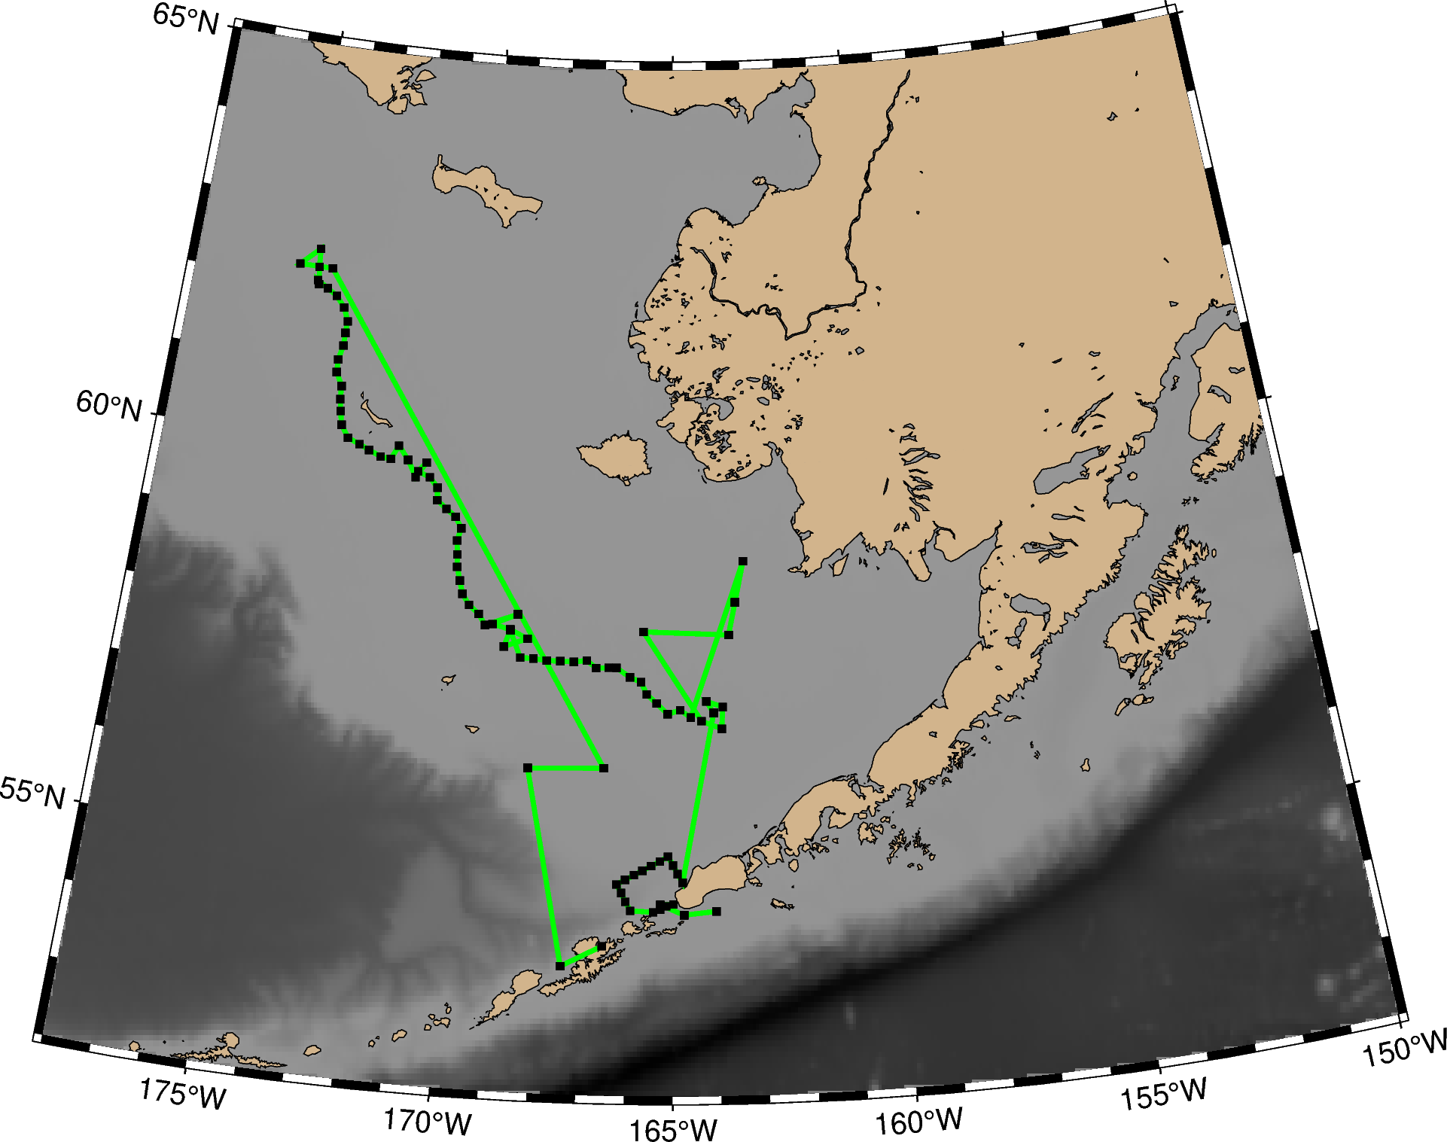

**Appendix 2. Map with directions to emergency department in Dutch Harbor, AK and Kodiak, AK**

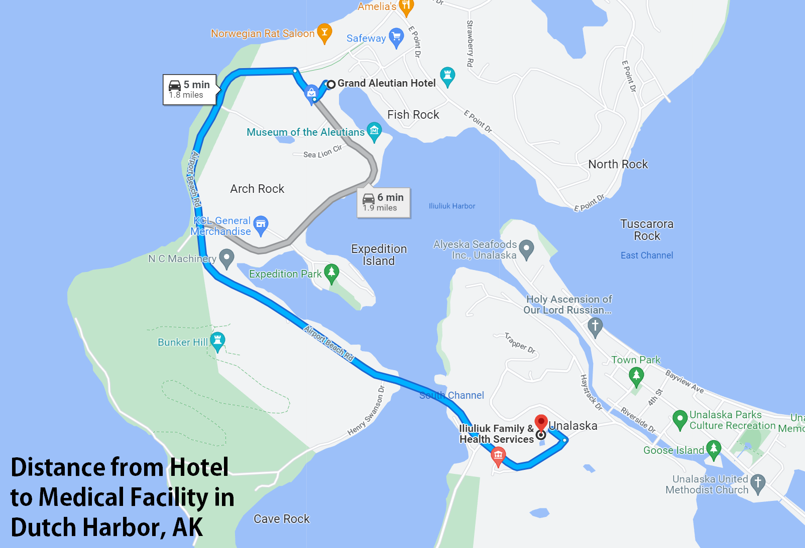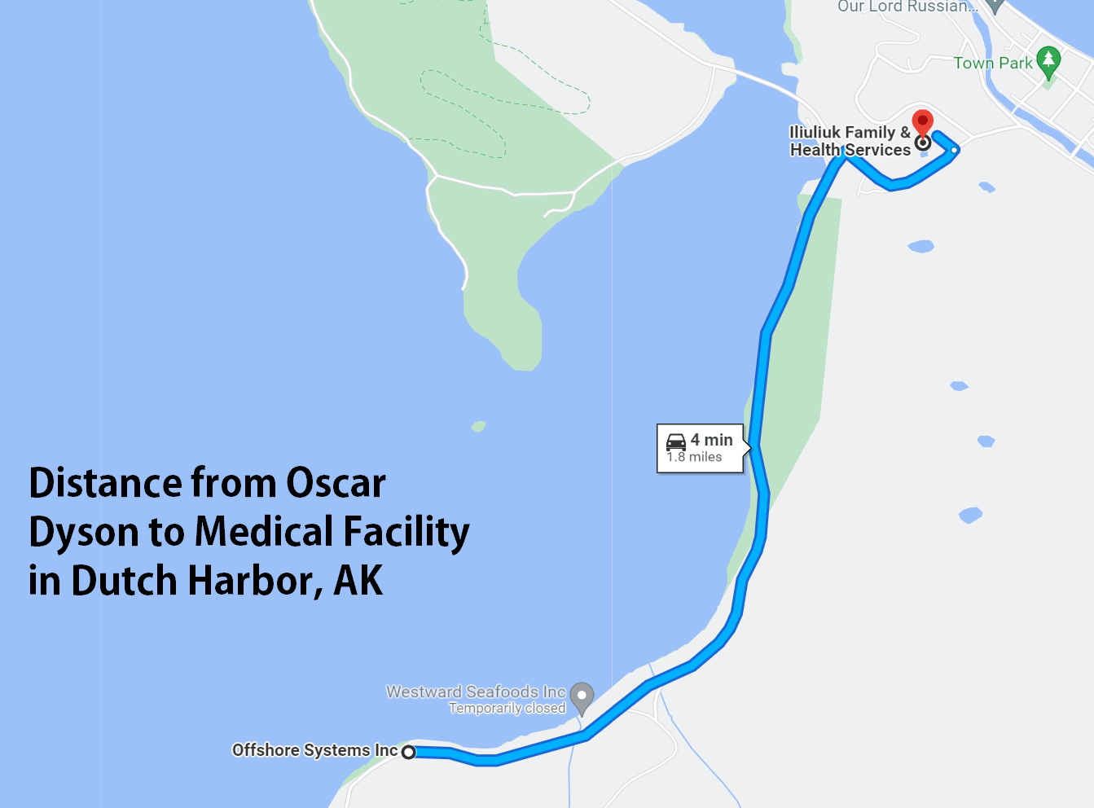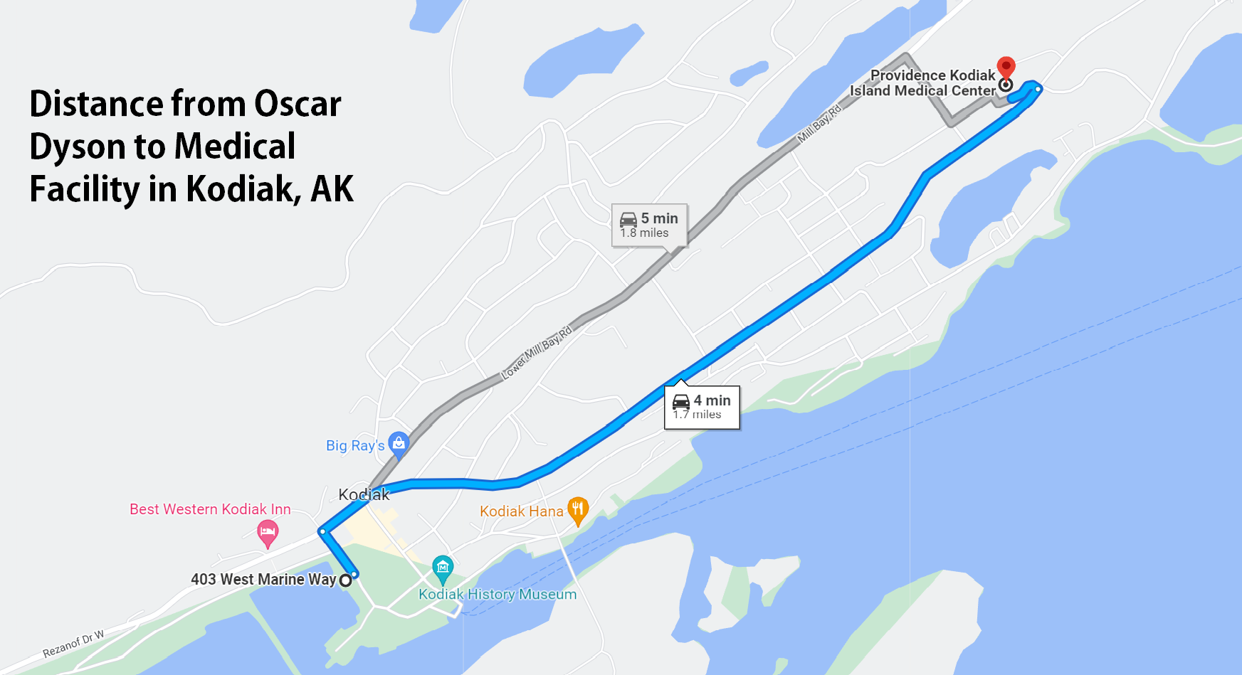

**Appendix 3. Participant Packing List including Supplemental COVID-19 Supplies**

**Personal Gear**

Mustang float coat

# Waterproof rain bib pant

Warm work gloves

Warm layers

Steel-toed boots

**COVID-19 Supplementary Gear**

Face Masks – Cloth or disposable (1/day for cloth or 5/day for disposable)

Gloves (5 pairs/ day)

Goggles/Eye Protection (1 pair/ person)

Disinfecting wipes

Hand sanitizer (1 small bottle/ person + extra)

**Appendix 4. First Aid Training Certification**

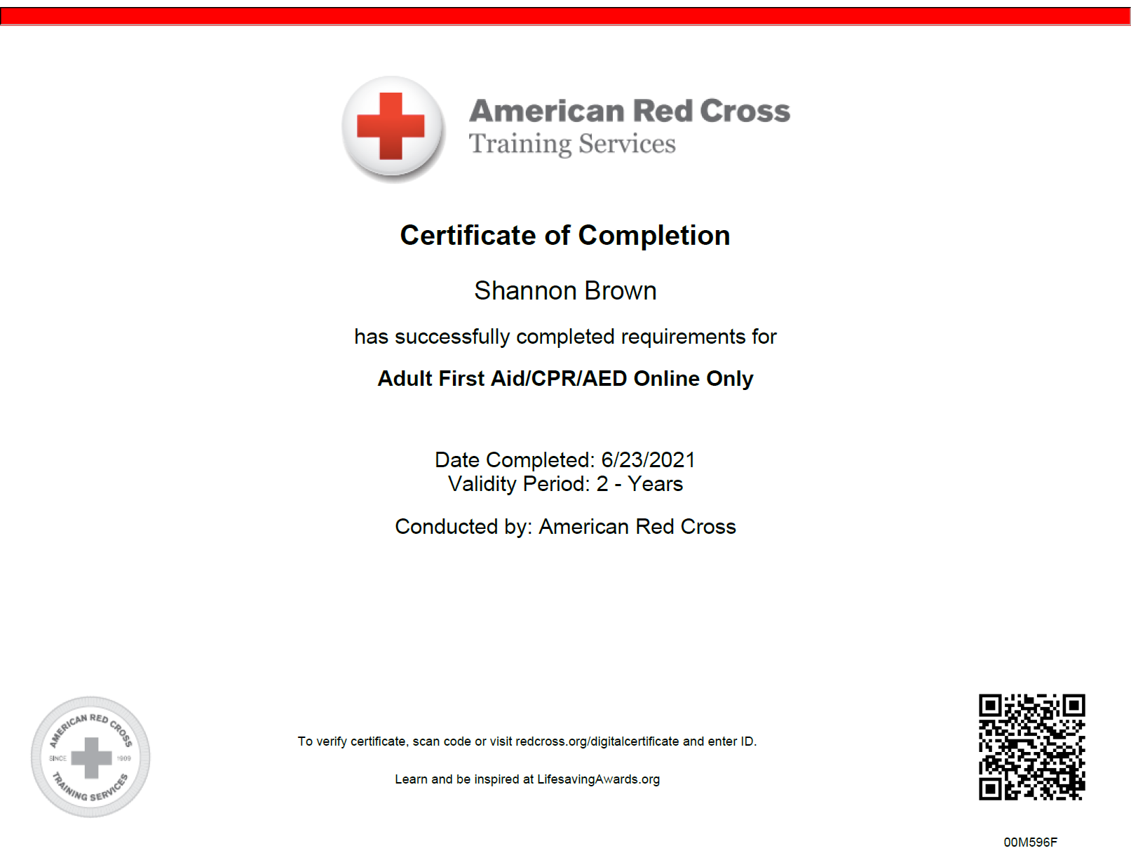

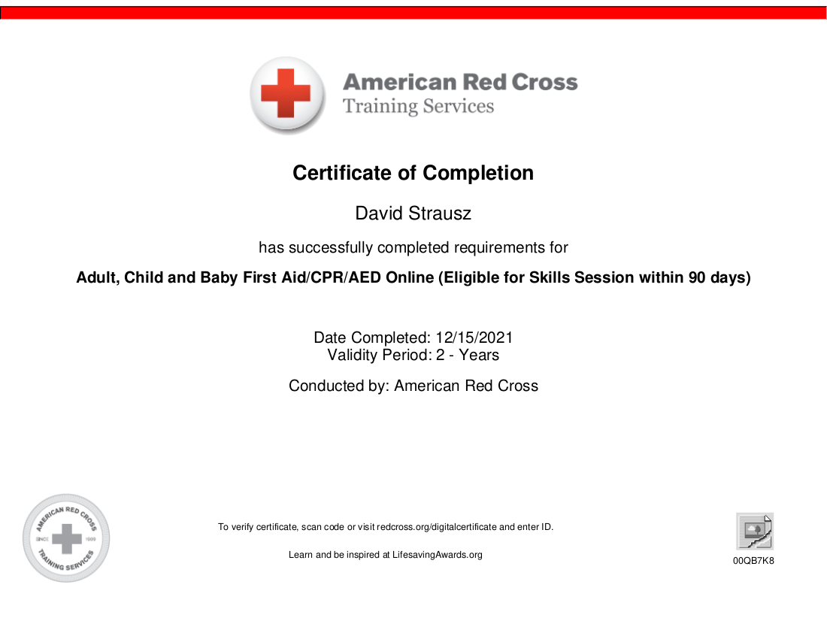

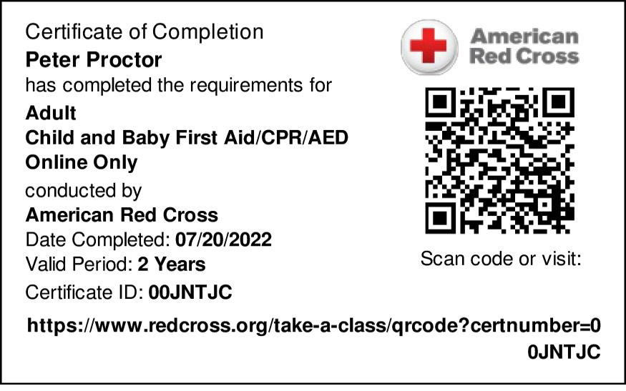

**Appendix 5. NOAA Cruise Instructions (Current Draft)**

**Draft - Project Instructions**

**Date Submitted:** Feb 22, 2023

**Platform:** NOAA Ship *Oscar Dyson*

**Project Number:** DY-23-06 (OMAO)

**Project Title:** EcoFOCI Spring Mooring Cruise and Hydrographic Survey

**Project Dates:** April 21, 2023 to May 7, 2023

Prepared by: ________________________ Dated: __________________  
 Shaun Bell

Chief Scientist

NOAA/PMEL

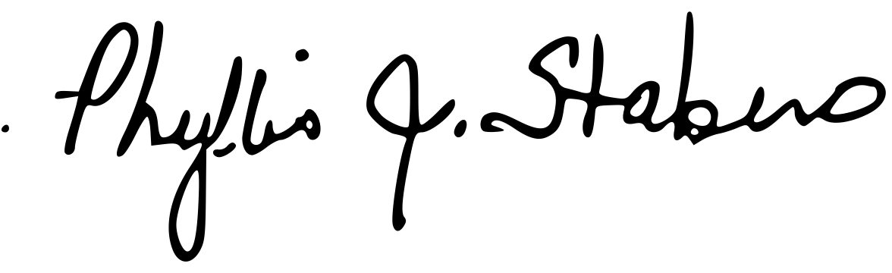

Approved by: Dated: 06 April, 2023  
 Dr. Phyllis Stabeno

Program Lead - EcoFOCI

NOAA/PMEL

Approved by: ________________________ Dated: __________________  
Dr. Michelle McClure   
Director - PMEL  
NOAA/PMEL

Approved by: ________________________ Dated: __________________

Captain Keith Golden, NOAA

Commanding Officer

Marine Operations Center – Pacific

**I. Overview**

A. Brief Summary and Project Period

EcoFOCI Spring Mooring cruise and hydrographic/biological survey; April 21, 2023 to May 7, 2023

B. Days at Sea (DAS)

Of the 17 DAS scheduled for this project, 15 DAS are funded by an OMAO allocation, 0 DAS are funded by a Line Office Allocation, 0 DAS are Program Funded, and 2 DAS are Other Agency funded. This project is estimated to exhibit a high Operational Tempo. This project will require operations up to 24 hrs./day.

C. Operating Area (include map/figure showing op area)

The operating area will consist of the Northern Gulf of Alaska along the Alaskan Peninsula from Kodiak to Unimak Pass and the Bering Sea with St Lawrence Island to the North, South to the Aleutian Chain and Unimak Pass, and longitude 177W degrees to the West and longitude 163W degrees to the east. The charts below in Appendix 1 shows the overall operating area along with charts for the operating area of each type of operation.

D. Summary of Objectives

This project is intended to recover five (5) PMEL subsurface moorings and one (1) PMEL surface mooring and to deploy eight (8) PMEL subsurface moorings and four (4) PMEL surface moorings at the Bering Sea sites of M2, M4, KU1, KU2, KU3,KU4 (recovery only), & UPP3 which is a site in the south of Unimak Pass. In addition, four (4) marine mammal moorings are to be recovered and four (4) marine mammal moorings will be deployed. A hydrographic/biological survey consisting of **C**onductivity/**T**emperature/**D**epth (**CTD**) casts, 20/60 cm bongo tows and **C**alifornia **V**ertical **E**gg **T**ows (**C**al**VET**s) in the Unimak Pass area, along the 70-meter isobath in the Bering Sea as far north as the sea ice permits, and in boxes around the 4 mooring sites at M2, M4, M5, & M8. Additionally, we will deploy up to two (2) popup buoys, up to four (4) satellite tracked drifters, up to two (2) gliders and up to 48 Sonobuoys.

E. Participating Institutions

NOAA – Pacific Marine Environmental Laboratory (PMEL)

7600 Sand Point Way NE

Seattle WA 98115

NOAA – Alaska Fisheries Science Center (AFSC)

7600 Sand Point Way NE

Seattle, WA 98115

Cooperative Institute for Climate, Ocean, and Ecosystem Studies (CICOES)

University of Washington

3737 Brooklyn Ave.

Seattle, WA 98105-6715

University of Alaska Fairbanks

[2150](https://maps.google.com/?q=24+Colovos+Rd.+%0D%0A+Durham,+NH+03824+%0D%0A+603&entry=gmail&source=g) Koyukuk Dr.

[Fairbanks,](https://maps.google.com/?q=24+Colovos+Rd.+%0D%0A+Durham,+NH+03824+%0D%0A+603&entry=gmail&source=g) AK 99775

US Fish and Wildlife Service, Alaska Region

1011 East Tudor Road

Anchorage, AK 99503

F. Personnel/Science Party: name, title, gender, affiliation, and nationality

| **Name (Last, First)** | **Title** | **Date Aboard** | **Date Disembark** | **Gender** | **Affiliation** | **Nationality** |
| --- | --- | --- | --- | --- | --- | --- |
| Bell, Shaun | Chief Scientist | 20-April-23 | 8-May-22 | M | NOAA/PMEL | US |
| Kimber, Brynn | Scientist | 20-April-23 | 8-May-22 | F | UW/AFSC | US |
| Harpold, Colleen | Scientist | 20-April-23 | 8-May-22 | F | NOAA/AFSC | US |
| Ekmanis, Iris | Scientist | 20-April-23 | 8-May-22 | F | NOAA Corps | US |
| Brown, Shannon | Scientist | 20-April-23 | 8-May-22 | F | UW/PMEL | US |
| Craig, Michael | Scientist | 20-April-23 | 8-May-22 | M | NOAA/PMEL | US |
| Paquin, Melanie | Scientist | 20-April-23 | 8-May-22 | F | NOAA/AFSC | US |
| Strausz, David | Scientist | 20-April-23 | 8-May-22 | M | UW/PMEL | US |
| Monaci, Natalie | Scientist | 20-April-23 | 8-May-22 | F | UAF | US |
| Proctor, Peter | Scientist | 20-April-23 | 8-May-22 | M | UW/PMEL | US |
| Bird Observer | Scientist | 20-April-23 | 8-May-22 | M/F | USGS | US |
| TBD | Scientist | 20-April-23 | 8-May-22 | M/F | Community Member | US |

G. Administrative

1. Points of Contact:

Shaun Bell (Scientist); NOAA, 7600 Sand Point Way NE, Bldg. 3, Seattle WA, 98115. PH: (206) 526-6884; [Shaun.Bell@noaa.gov](mailto:Shaun.Bell@noaa.gov)

Dr. Phyllis Stabeno (Program Director, Eco-FOCI); 7600 Sand Point Way NE, Bldg. 3, Seattle, WA 98115. PH: (206) 526-6453; [Phyllis.Stabeno@NOAA.GOV](mailto:Phyllis.Stabeno@NOAA.GOV)

Dr. Julie Kiester, AFSC (Program Director, FOCI); 7600 Sand Point Way NE, Bldg. 4; Seattle, WA 98115. PH: (206) 526-4231; [Libby.logerwell@NOAA.GOV](mailto:Libby.logerwell@NOAA.GOV)

Operations Officer, NOAAS Oscar Dyson; 2002 SE Marine Science Drive, Newport, OR 97365. PH: (541) 867-8911 (Ship’s VOIP); [OPS.Oscar.Dyson@NOAA.GOV](mailto:OPS.Oscar.Dyson@NOAA.GOV)

2. Diplomatic Clearances

None required.

3. Licenses and Permits

This project will be conducted under Scientific Research Permit (U.S.) (SRP) #2023-B1; effective dates 06 February 2022 to 30 September, 2023. Issued to Robert Foy, Science and Research Director-AFSC.

NPRW photos will be conducted under Research Permit #25563. Issued to John Bengtson, Marine Mammal Laboratory-AFSC.

**II. Operations**

The Chief Scientist is responsible for ensuring the scientific staff are trained in planned operations and are knowledgeable of project objectives and priorities. The Commanding Officer is responsible for ensuring all operations conform to the ship’s accepted practices and procedures.

A. Project Itinerary:

Scientists report to ship Monday April 19, 2022. Gear loading begins.

Departure: Kodiak, Monday, April 21, 2022

Arrival: Dutch Harbor, Saturday, May 7, 2022

Offload gear upon arrival, Scientist depart ship upon completion of offload.

B. Staging and De-staging:

Two 40-foot containers will be shipped from Seattle and will be staged at the city Pier in Kodiak. Unloading of the containers and the transfer of equipment to the ship shall occur as appropriate prior to departure. Members of the science party will arrive at least two days prior to departure to assist in the loading of equipment onto the ship, preparation of the moorings and setting up the sampling gear on deck and in the labs. The science party will arrange their own vehicles for transporting personnel and equipment. At the end of the project, all equipment will be removed from the ship and offloaded into a container in Dutch Harbor for shipment back to Seattle. To assist in the unloading of the containers and setting up the moorings, a crane operator will be needed during normal working hours on Wednesday, April 19th and Thursday, April 20th. Additionally, a crane operator will be needed on May 7th to off-load equipment to be packed into the container for shipment to Seattle.

C. Operations to be Conducted:

* 1. **Unimak Box CTDs:** CTDs will be taken at each of 18 stations in the “box” in and around Unimak Pass. At each station within the pass and at every other station along the sides and across the northern line, a 20/60 cm bongo net will be towed for the collection of zooplankton.
  2. **FOCI Bering Sea Mooring Sites M2, M4, M5, M8, and KU(1-4):** Depending upon arrival time, the operations at site 2 will commence with mooring operations or the CTD box. Mooring operations will consist of the recovery of existing moorings at each relevant site, which includes two (2) subsurface mooring at M2 and two (2) subsurface moorings at site M4. The KU4 RISE mooring will also be recovered. This is a refloatable mooring that should have a surface representation; however, due to Typhoon Merbok in the fall of 2022, this mooring may be at the bottom and need to be dragged (water depth ~50 m). Each relevant site will have mooring deployments. These include deployment of three (3) subsurface mooring and one (1) surface moorings at site M2 and two (2) subsurface moorings at site M4, three (3) surface moorings, one each, at KU1, KU2, and KU3 and two (2) subsurface moorings at KU1 and KU2. For relevant M-sites the CTD box will consist of a CTD and 20/60 cm bongo at each of four (4) corner stations of the box and a CTD, bongo and three (3) CalVET tows at the location of the mooring in the center of the box. Depending upon water sampling requirements, the CTD at the mooring location may have to be done twice to get adequate water samples. The ship will also be tasked with returning to the mooring site up to 24 hours after mooring deployment for additional calibration casts at Site 2. The CTD at the mooring location will serve as a calibration CTD for the moorings. This scenario will be repeated at site M4 with just the CTD boxes being completed at sites M5 and M8. Sites M5 and M8 will only be occupied if the sea is free of ice.
  3. **FOCI Gulf of Alaska Mooring site UPP3:** A mooring will be recovered and deployed at site UPP3 (Unimak Pass). A CTD cast will be performed at the site.
  4. **70-meter Isobath Survey Line:** A CTD cast with sampling for salinity, chlorophyll, nutrients and oxygen will be conducted at each station along the 70-meter isobath. Stations will commence at Mooring Site 2 and continue as far north as sea ice permits up to Site 8. CTDs will be conducted to within 5 meters of the bottom unless it is deemed prudent to only go to 10 meters, such as when the ship’s motion is such that the CTD may hit the bottom. Winch speeds should be 30 meters/minute on the down and up cast. A 20/60 cm bongo tow will be conducted at every other station along the 70m isobath survey line.
  5. **Larval Survey Stations:** A 20/60 cm bongo tow will be performed at each of 27 survey stations as time permits. These stations are located near the middle of the 72 m isobath in the area of the Pribilof Islands. Some of these stations will also have corresponding CTDs depending on how much time is allotted to the survey grid.
  6. **Marine Mammal Moorings:** Marine mammal moorings will be turned around at mammal sites near Pribilof Canyon, Unimak Pass, BS10, and Umnak Pass. CTD’s will be conducted at each of these sites to validate the sound velocity.
  7. **Sonobuoys:** Up to48Sonobuoys will be deployed over the side while transiting between stations and every ~3 hours while transiting over long periods of time for documentation of marine mammals. VHF antennas (provided by AFSC) will need to be mounted on the ship's flying bridge before departure. A GPS feed will be required on the bridge for the monitoring station.
  8. **Popup Moorings:** Up to two (2) popup moorings will be deployed during the cruise throughout the Bering Sea. The popup moorings can be deployed easily from the side of the vessel by being lowered to the water surface with a hand line and released or by a quick release using the outhaul on the A-frame.
  9. **Seabird Observations:** Observations of seabirds will be conducted whenever underway during daylight hours if visibility and the ship’s transit speed permit.
  10. **Underway System:** The underway system will be adapted such that a TDGP (Total dissolved gas pressure) instrument can be added to the system. This will be done in conjunction with the CO2 program. Survey and Science will work together to make this modification.
  11. **Drogued Drifters:** up to four (4) drogued drifters will be deployed during the cruise throughout the Bering Sea. They can be deployed easily from the side of the vessel by being lowered to the water surface with a hand line and released.
  12. **Glider Deployment:** up to two (2) Oculus gliders will be deployed during the cruise. These are remotely operated gliders that will transverse the 70m line beginning around M4 and heading in two different directions (N and S) along the 70m isobath. Ideal deployment and recovery of the gliders would be from a small boat, weather permitting. If deploying gliders from an A-frame or crane, a quick release device should be used to disconnect the glider from the lifting line. Recovering the glider off of a ship requires lassoing the gliders back fin and lifting the glider out of the water. This can be risky in rough seas. The vessel needs to remain in the area of deployment until it is confirmed the glider is working appropriately and to recover an aborted deployment if necessary. This will likely mean keeping operations in the area for no fewer than 6 hours

D. Dive Plan

All dives are to be conducted in accordance with the requirements and regulations of the NOAA Diving Program (<http://www.ndc.noaa.gov/dr.html>) and require the approval of the ship’s Commanding Officer.

Dives are not planned for this project.

E. Applicable Restrictions

Poor weather, equipment failure, unforeseen conditions, and ice coverage would all preclude normal operations. Poor weather would have to be waited out or the project track would have to be modified to provide the best prospects for completing the project. A-frame and winch failures would have to be addressed immediately for the project to continue. Ice coverage would negate the ability to conduct mooring and/or CTD/Bongo operations; these would have to be postponed for later in the project, or conducted during subsequent projects or from another vessel. Additionally, surface floats will not be deployed if there is a possibility of ice in their location.

**III. Equipment**

A. Equipment and Capabilities provided by the ship (itemized)

Hydrographic winch with slip rings and 2-conductor cable terminated for the CTD,

Sea-Bird Electronics’ SBE 911 plus CTD system with stand and dual Temperature and Conductivity sensors, each CTD system should include underwater CTD, weights, and altimeter, there should be a deck unit for the system,

10-liter Niskin sampling bottles for use with the CTD rosette (11 bottles plus 4 spares).

A second hydrographic winch with slip rings and 2-conductor cable terminated for the SBE 19plus for net tow operations – bongos and CalVETs.

12 kHz hull mounted EdgeTech Acoustic release transducer and deck unit,

Scientific Computer System (SCS),

For meteorological observations: 2 anemometers (one R. M. Young system interfaced with the SCS), calibrated air thermometer (wet- and dry-bulb) and a calibrated barometer and/or barograph,

Freezer space for storage of biological and chemical samples (-20° and -80°C), turned on and operating,

SIMRAD ES-60 and EK-80 echo sounders,

A minimum of two (2) computer workstations in the acoustic lab with Internet, printer and email access,

Removable stern platform in place,

Laboratory space with storage space,

Underway flow-through seawater system with TSG,

Seawater hoses and nozzles to wash nets,

Adequate deck lighting for nighttime operations,

Navigational equipment including GPS and radar,

Safety harnesses and floatation equipment for working on the side sample platform and fantail,

Ship’s cranes used for loading and/or recovering and deploying moorings,

Work boat available for mooring repairs or recovery if needed and for glider deployment or retrieval.

B. Equipment and Capabilities provided by the scientists (itemized)

Sea-Bird Electronics SBE 19 Plus SEACAT system,

Fluorometer, light meter (PAR), and dual oxygen systems to be mounted on the CTD (backup),

Ancillary PAR sensors to be mounted to CTD frame.

Eight (8) Subsurface moorings, floats, instruments, chain,

Four (4) Surface moorings, floats, instruments, chain,

Four (4) Marine Mammal subsurface moorings, floats, instruments, chain

Two (2) Popup buoys,

Equipment to deploy and recover moorings including titanium hooks and telescoping poles,

Dragging gear as needed to drag for moorings in event of failure to release,

20/60 cm bongo net systems,

Manual wire angle indicator,

CalVET net sampling system,

Underway system instrumentation including TDGP+oxygen sensor.

Scientific sampling supplies and storage/preservation supplies,

One case of 48 sonobuoys.

Estimated weights of the gear is shown in the table in appendix IV. A final weight will be tallied upon loading the containers at PMEL. All parcels loaded into the container will be tagged with their weight. This list will be passed to the Captain upon loading and the total weight to be loaded onto the ship will not exceed 38,000 pounds.

**IV. Hazardous Materials**

A. Policy and Compliance

The Chief Scientist is responsible for complying with FEC 07 Hazardous Materials and Hazardous Waste Management Requirements for Visiting Scientific Parties (or the OMAO procedure that supersedes it). By Federal regulations and NOAA Marine and Aviation Operations policy, the ship may not sail without a complete inventory of all hazardous materials by name and quantity, MSDS, appropriate spill cleanup materials (neutralizing agents, buffers, or absorbents) in amounts adequate to address spills of a size equal to the amount of chemical brought aboard, and chemical safety and spill response procedures. Documentation regarding those requirements will be provided by the Chief of Operations, Marine Operations Center, upon request.

Per OMAO procedure, the scientific party will include with their project instructions and provide to the CO of the respective ship 30 days before departure:

* List of chemicals by name with anticipated quantity
* List of spill response materials, including neutralizing agents, buffers, and absorbents
* Chemical safety and spill response procedures, such as excerpts of the program’s Chemical Hygiene Plan or SOPs relevant for shipboard laboratories
* For bulk quantities of chemicals in excess of 50 gallons total or in containers larger than 10 gallons each, notify ship’s Operations Officer regarding quantity, packaging and chemical to verify safe stowage is available as soon as chemical quantities are known.

Upon embarkation and prior to loading hazardous materials aboard the vessel, the scientific party will provide to the CO or their designee:

* An inventory list showing actual amount of hazardous material brought aboard
* An MSDS for each material
* Confirmation that neutralizing agents and spill equipment were brought aboard sufficient to contain and cleanup all of the hazardous material brought aboard by the program
* Confirmation that chemical safety and spill response procedures were brought aboard

Upon departure from the ship, scientific parties will provide the CO or their designee an inventory showing that all chemicals were removed from the vessel. The CO’s designee will maintain a log to track scientific party hazardous materials. MSDS will be made available to the ship’s complement, in compliance with Hazard Communication Laws.

Scientific parties are expected to manage and respond to spills of scientific hazardous materials. Overboard discharge of hazardous materials is not permitted aboard NOAA ships.

B. Inventory

**Oxygen Analysis Chemicals, property of PMEL:**

| **Common Name** | **Concentration** | **Qty** | **Trained**  **Individual** | **Spill Response** | **Notes** |
| --- | --- | --- | --- | --- | --- |
| Manganese Chloride | 3 M | 2 x 500 ml | Shaun Bell | Gloves, Paper Towels, Kitty litter, Plastic bags | Not a regulated chemical /solution. |
| Potassium Iodate | 0.00234 M | 2 x 500 ml | Shaun Bell | Spill Control PI, Gloves, Kitty litter, Plastic bags | Store in Acid Locker in Chem. Lab. |
| Sodium Iodide/NaOH Solution | 4 M NaI, 8 M NaOH | 2 x 500 ml | Shaun Bell | Spill Control B | Store in Acid Locker in Chem. Lab. |
| Sodium Thiosulfate | 0.16 M | 2 x 500 ml | Shaun Bell | Spill Control ST | Store in Acid Locker in Chem. Lab. |
| Sulfuric Acid | 5 M | 2 x 500 ml | Shaun Bell | Spill Control A | Store in Acid Locker in Chem. Lab. |

**Fish/Zooplankton sampling chemicals, property of NMFS:**

| **Common Name /Responsibility** | **Concentration** | **Qty** | **Trained**  **Individual** | **Spill Response** | **Notes** |
| --- | --- | --- | --- | --- | --- |
| Ethanol/FOCI | 100% | 5 – 1-gallon plastic jugs | Deana Crouser | Spill Response E, Gloves, 3M absorbent Pads, Plastic bags | Store in Chem Lab, yellow flammable locker |
| Formaldehyde /FOCI | 37% | 4 – 2.5-gallon barrels | Deana Crouser | Spill Control F, Gloves, eye protection, Fan-Pads, Foramalex, PolyForm-F, plastic bags | Store in Fish Lab Flammable cabinets. Will need to place 4 in each cabinet. |
| Sodium Borate Solution/FOCI | 5-6% | 1 – 5-gallon carboy | Deana Crouser | Gloves, Paper towels, plastic bags | Not a regulated chemical. Working container will be secured on Fish Lab bench |
| Sodium Borate Powder/FOCI | 100% | 1 – 500 g | Deana Crouser | Gloves, wet paper towels, plastic bags | Not a regulated chemical, stored in Spill kit |

**UAF Chemicals:**

| **Common Name** | **Concentration** | **Qty** | **Trained Individual** | **Spill Response** | **Notes** |
| --- | --- | --- | --- | --- | --- |
| Compressed Air | Calibration gas used in the CO2 system on Peggy Buoy | 2 tanks (roughly the size of dive tanks) | Natalie Monaci | NA |  |
| Mercuric Chloride | Saturated Solution | 0.10 liter | Natalie Monaci | Spill Control M |  |

**eDNA Chemicals:**

| **Common Name** | **Concentration** | **Qty** | **Trained Individual** | **Spill Response** | **Notes** |
| --- | --- | --- | --- | --- | --- |
|  |  |  |  |  |  |
| Ethanol/eDNA | 95% | 1 - 400ml  10-50ml | Shannon Brown | Spill Response E, Gloves, 3M absorbent Pads, Plastic bags | Store in Chem Lab, yellow flammable locker |
| EtOH (Ethyl Alcohol) | 95% | 2 liter | Shannon Brown | Spill Response E, Gloves, 3M absorbent Pads, Plastic bags | stored within a plastic box on our automated sampler, |

C. Chemical safety and spill response procedures

**A: ACID**

* Wear appropriate protective equipment and clothing during clean-up. Keep upwind. Keep out of low areas.
* Ventilate closed spaces before entering them.
* Stop the flow of material, if this is without risk. Dike the spilled material, where this is possible.
* **Large Spills**: Dike far ahead of spill for later disposal. Use a non-combustible material like vermiculite, sand or earth to soak up the product and place into a container for later disposal.
* **Small Spills**: Wipe up with absorbent material (e.g. cloth, fleece). Clean surface thoroughly to remove residual contamination.
* Never return spills in original containers for re-use.
* Neutralize spill area and washings with soda ash or lime. Collect in a non-combustible container for prompt disposal.

**B: BASE**

* Wear appropriate protective equipment and clothing during clean-up. Keep upwind. Keep out of low areas.
* Ventilate closed spaces before entering them.
* Stop the flow of material, if this is without risk. Dike the spilled material where this is possible.
* **Large Spills**: Dike far ahead of spill for later disposal. Use a non-combustible material like vermiculite, sand or earth to soak up the product and place into a container for later disposal.
* **Small Spills**: Wipe up with absorbent material (e.g. cloth, fleece). Clean surface thoroughly to remove residual contamination.
* Never return spills in original containers for re-use.
* Neutralize spill area and washings with dilute acid such as 10% HCl if possible. Collect in a non-combustible container for prompt disposal.

**E: Ethanol**

* Ventilate area of leak or spill. Remove all sources of ignition.
* Wear appropriate personal protective equipment.
* Isolate hazard area. Keep unnecessary and unprotected personnel from entering. Contain and recover liquid when possible.
* Use non-sparking tools and equipment. Collect liquid in an appropriate container or absorb with an inert material (e. g., vermiculite, dry sand, earth), and place in a chemical waste container.
* Do not use combustible materials, such as saw dust.

**F: Formalin/Formaldehyde**

* Ventilate area of leak or spill. Remove all sources of ignition.
* Wear appropriate personal protective equipment.
* Isolate hazard area. Keep unnecessary and unprotected personnel from entering. Contain and recover liquid when possible.
* Use non-sparking tools and equipment. Collect liquid in an appropriate container or absorb with an inert material (e. g., vermiculite, dry sand, earth), and place in a chemical waste container.
* Do not use combustible materials, such as saw dust.

**M: Mercury**

* Spills: Pick up and place in a suitable container for reclamation or disposal in a method that does not generate dust. Sprinkle area with sulfur or calcium polysulfide to suppress mercury. Use Mercury Spill Kit if need be.

**PI: Potassium Iodate**

* Wear appropriate personal protective equipment.
* Avoid contact with combustibles (wood, paper, clothing, etc.)
* Absorb with kitty litter or vermiculite.
* Do not use combustible materials, such as saw dust.
* Keep substance damp with water spray.
* Vacuum or sweep up material and place into suitable disposable container (plastic bags).

**ST: Sodium Thiosulfate**

* Ventilate area of leak or spill.
* Wear appropriate personal protective equipment.
* Use chemical safety goggles. Maintain eye wash fountain and quick-drench facilities in work area.
* Avoid contact with combustibles (wood, paper, clothing, etc.)
* Absorb with kitty litter or vermiculite.
* Do not use combustible materials, such as saw dust.
* Recover liquid or particulate in 5-gallon bucket.

**PMEL Acid-Base Spill Kit Contents:**

| **Common Name** | **Amount** | **Use** | **Total Spill Volume Controllable** | **Notes** |
| --- | --- | --- | --- | --- |
| Spilfyter Acid Neutralizer | 1 Box | Clean up acid spill – H2SO4 | 1.5 liters of 5M Sulfuric Acid |  |
| Spilfyter Base Neutralizer | 1 Box | Clean up base spill – NaOH | 2.0 liters of NaOH |  |
| Vinyl Gloves | 1 box each M, L and XL | Protect hands during all cleanups | NA |  |
| Foxtail/Dust pan | 1 each | Pick up absorbed neutralizer | NA |  |
| Rubber Apron | 1 each | Protect personnel during cleanup | NA |  |
| Paper Towels | 1 roll | Absorb small amounts of liquids | NA |  |
| Goggles | 2 pair | Protect eyes during cleanups | NA |  |
| Chemical Absorbent (kitty litter) | 1 liter | Absorb liquids | 0.5 liters |  |
| Plastic Bags | 2 each | Contain used absorbents/waste | NA |  |

**FOCI Spill Kit Contents:**

| **Common Name** | **Amount** | **Use** | **Total Spill Volume Controllable** | **Notes** |
| --- | --- | --- | --- | --- |
| Formalex | 1 – 5 gallons 2 – 1 gallon | Formaldehyde cleanup, (all concentrations) | 1:1 control | Formalex will be used in conjunction with Fan-Pads to reduce spill volumes. |
| Fan-Pads | 2 rolls (50 sheets per roll) | Formaldehyde cleanup, (all concentrations) | 50 sheets = 50 – 150 ml spills | Formalex will be used in conjunction with Fan-Pads to reduce spill volumes. |
| PolyForm-F | 1 – 5-gallon bucket | Formaldehyde cleanup, (all concentrations) | 1:1 control | Pour onto large spill immediately to deactivate formaldehyde. |
| 3 M Pads | 10 pads | Ethanol cleanup | 10 pads = 10 – 250 ml spills | Pads may be reused if dried out under fume hood. |
| Nitrile Gloves | 8 pairs each: S, M, L, XL | For all cleanup procedures | NA | Gloves will be restocked by each survey group. |
| Eye protection | 4 pairs goggles,1 face shield | Formaldehyde cleanup | NA | Eye protection will be cleaned before reuse |
| Tyvek Lab Coats | 2 coats | Formaldehyde cleanup | NA | Coats will be cleaned with Fan-Pads and Formalex before reuse. |
| Plastic Bags | 2 | Formaldehyde cleanup/Fan-Pads | NA | Bags may be packed full and sealed. |

D. Radioactive Materials

No Radioactive Isotopes are planned for this project.

E. Lithium batteries

1. Lithium Batteries, property of PMEL:

| **Size** | **Qty** | **Spill Response** | **Notes** |
| --- | --- | --- | --- |
| 9V | 48 | NA | In SeaBird and WET Labs instruments |
| AA | 152 | NA | In SeaBird instruments and MicroCATs Saft LS14500 |
| D | 0 | NA | In RCM9 |
| BCX85D | 32 | NA | In Prawler moored instrument package |
| DL123 6V | 48 | NA | In Sonobuoys |

2. Lithium Battery Risk Management Plan:

a. All lithium batteries are packaged under UN3091, contained within equipment.

b. No equipment will be opened up while at sea to change out batteries.

c. All equipment with batteries shipped to the Dyson will be deployed on moorings.

d. All moorings recovered with instruments containing Li batteries will be shipped back to PMEL upon completion of the cruise for proper care and disposal.

e. Instruments containing Li batteries will be stored on the back deck in a wire cage or in the sorting lab in boxes labeled as containing Li batteries. The operations officer will be alerted to these locations.

**V. Additional Projects**

A. Supplementary (“Piggyback”) Projects

No Supplementary Projects are planned.

B. NOAA Fleet Ancillary Projects

No NOAA Fleet Ancillary Projects are planned.

**VI. Disposition of Data and Reports**

Disposition of data gathered aboard NOAA ships will conform to NAO 216-101 *Ocean Data Acquisitions* and NAO 212-15 *Management of Environmental Data and Information.* To guide the implementation of these NAOs, NOAA’s Environmental Data Management Committee (EDMC) provides the *NOAA Data Documentation Procedural Directive* (data documentation) and *NOAA Data Management Planning Procedural Directive* (preparation of Data Management Plans). OMAO is developing procedures and allocating resources to manage OMAO data and Programs are encouraged to do the same for their Project data.

1. Data Classifications: *Under Development*
   1. OMAO Data
   2. Program Data
2. Responsibilities: *Under Development*

**VII. Meetings, Vessel Familiarization, and Project Evaluations**

1. Pre-Project Meeting: The Chief Scientist and Commanding Officer will conduct a meeting of pertinent members of the scientific party and ship’s crew to discuss required equipment, planned operations, concerns, and establish mitigation strategies for all concerns. This meeting shall be conducted before the beginning of the project with sufficient time to allow for preparation of the ship and project personnel. The ship’s Operations Officer usually is delegated to assist the Chief Scientist in arranging this meeting.
2. Vessel Familiarization Meeting: The Commanding Officer is responsible for ensuring scientific personnel are familiarized with applicable sections of the standing orders and vessel protocols, e.g., meals, watches, etiquette, drills, etc. A vessel familiarization meeting shall be conducted in the first 24 hours of the project’s start and is normally presented by the ship’s Operations Officer.
3. Post-Project Meeting: The Commanding Officer is responsible for conducting a meeting no earlier than 24 hrs. before or 7 days after the completion of a project to discuss the overall success and shortcomings of the project. Concerns regarding safety, efficiency, and suggestions for future improvements shall be discussed and mitigations for future projects will be documented for future use. This meeting shall be attended by the ship’s officers, applicable crew, the Chief Scientist, and members of the scientific party and is normally arranged by the Operations Officer and Chief Scientist.
4. Project Evaluation Report: Within seven days of the completion of the project, a Customer Satisfaction Survey is to be completed by the Chief Scientist or Principal Investigator, as appropriate. The form is available at [https://sites.google.com/a/noaa.gov/omao-intranet-dev/operations/marine/customer-satisfaction-survey](https://docs.google.com/a/noaa.gov/forms/d/1a5hCCkgIwaSII4DmrHPudAehQ9HqhRqY3J_FXqbJp9g/viewform) and provides a “Submit” button at the end of the form. It is also located at <https://docs.google.com/a/noaa.gov/forms/d/1a5hCCkgIwaSII4DmrHPudAehQ9HqhRqY3J_FXqbJp9g/viewform>. Submitted form data is deposited into a spreadsheet used by OMAO management to analyze the information. Though the complete form is not shared with the ships, specific concerns and praises are followed up on while not divulging the identity of the evaluator.

**VIII. Miscellaneous**

A. Meals and Berthing

The ship will provide meals for the scientists listed above. Meals will be served 3 times daily beginning one hour before scheduled departure, extending throughout the project, and ending two hours after the termination of the project. Since the watch schedule is split between day and night, the night watch may often miss daytime meals and will require adequate food and beverages (for example a variety of sandwich items, cheeses, fruit, milk, juices) during what are not typically meal hours. Special dietary requirements for scientific participants will be made available to the ship’s command at least seven days prior to the project.

Berthing requirements, including number and gender of the scientific party, will be provided to the ship by the Chief Scientist. The Chief Scientist and the Operations Officer will work together on a detailed berthing plan to accommodate the gender mix of the scientific party taking into consideration the current makeup of the ship’s complement. The Chief Scientist is responsible for ensuring the scientific berthing spaces are left in the condition in which they were received; for stripping bedding and linen return; and for the return of any room keys which were issued. Unless prior arrangements are made, the science party may move aboard the night before scheduled departure and must move off the ship the day after scheduled arrival (at the end of project). The Chief Scientist/Principal Investigator is also responsible for the cleanliness of the laboratory spaces and the storage areas utilized by the scientific party, both during the project and at its conclusion prior to departing the ship.

All NOAA scientists will have proper travel orders when assigned to any NOAA ship. The Chief Scientist will ensure that all non-NOAA or non-Federal scientists aboard also have proper orders. It is the responsibility of the Chief Scientist or Principal Investigator to ensure that the entire scientific party has a mechanism in place to provide lodging and food and to be reimbursed for these costs in the event that the ship becomes uninhabitable and/or the galley is closed during any part of the scheduled project.

All persons boarding NOAA vessels give implied consent to comply with all safety and security policies and regulations which are administered by the Commanding Officer. All spaces and equipment on the vessel are subject to inspection or search at any time. All personnel must comply with OMAO's Drug and Alcohol Policy dated May 17, 2000, which forbids the possession and/or use of illegal drugs and alcohol aboard NOAA Vessels.

B. Medical Forms and Emergency Contacts

The NOAA Health Services Questionnaire (NHSQ, NF 57-10-01 (3-14)) must be completed in advance by each participating scientist. The NHSQ can be obtained from the Chief Scientist or the NOAA website <http://www.corporateservices.noaa.gov/noaaforms/eforms/nf57-10-01.pdf>.

NHSQs must be submitted every 2 years for individuals under the age of 50 and every 1 year for ages 50 and above. NHSQs must be accompanied by [NOAA Form (NF) 57-10-02](http://www.corporateservices.noaa.gov/~noaaforms/eforms/nf57-10-02.pdf) - Tuberculosis Screening Document in compliance with [OMAO Policy 1008](http://www.omao.noaa.gov/find/media/documents/omao-1008-tuberculosis-protection-program) (Tuberculosis Protection Program). A copy of current covid vaccination status shall also be provided to NOAA Health.

The completed forms should be sent to Marine Health Services at the applicable Marine Operations Center. The NHSQ and Tuberculosis Screening Document should reach the Health Services Office no later than 4 weeks prior to the start of the project to allow time for the participant to obtain and submit additional information should health services require it, before clearance to sail can be granted. Please contact MOC Health Services with any questions regarding eligibility or completion of either form. Ensure to fully complete each form and indicate the ship or ships the participant will be sailing on. The participant will receive an email notice when medically cleared to sail if a legible email address is provided on the NHSQ.

The participant can mail, fax, or email the forms to the contact information below. Participants should take precautions to protect their Personally Identifiable Information (PII) and medical information and ensure all correspondence adheres to DOC guidance (<http://ocio.os.doc.gov/ITPolicyandPrograms/IT_Privacy/PROD01_008240>).

The only secure submission process approved by NOAA is [kiteworks](https://sfc.doc.gov/) by Accellion Secure File Transfer, which requires the sender to set up an account using a valid NOAA email address and password. User accounts may expire after 30 days of inactivity. Simply re-register to send and receive files.

Persons without a NOAA email account must fax or mail their forms.

Contact information:

| Marine Health Services  Marine Operations Center – Pacific  2002 SE Marine Science Dr.  Newport, OR 97365  Telephone 541-867-8822  Fax 541-867-8856  Email [MOP.Health-Services@noaa.gov](mailto:MOP.Health-Services@noaa.gov) |  |
| --- | --- |

Prior to departure, the Chief Scientist must provide an electronic listing of emergency contacts to the Executive Officer for all members of the scientific party, with the following information: contact name, address, relationship to member, and telephone number.

C. Shipboard Safety

All personnel who embark are to fully support and comply with NOAA Administrative Order 202-1106: NOAA Sexual Assault and Sexual Harassment Prevention and Response Policy.  The at-sea working/living environment is particularly sensitive and it is incumbent upon all personnel to uphold a positive and professional workplace dynamic in order to successfully accomplish cruise objectives.

Surge protectors, power strips and Uninterrupted Power Sources (UPS) must be approved for marine/shipboard use, removed from service if hot to the touch, regularly inspected for damage or wear, limited to one surge protector per duplex receptacle (i.e., “outlet”), and never daisy chained. The equipment must meet MIL Performance Specification MIL-PZRF-32167A, which incorporates ASTM F1507 (Standard Specifications for Surge Suppressors for Shipboard Use) and UL 1449 (Safety Standards for Surge Protective Devices).

Hard hats are required when working with suspended loads.  Work vests are required when working near open railings and during small boat launch and recovery operations.  Hard hats and work vests will be provided by the ship when required.

Wearing open-toed footwear or shoes that do not completely enclose the foot (such as sandals or clogs) outside of private berthing areas is not permitted.  At the discretion of the ship CO, safety shoes (i.e. steel or composite toe protection) may be required to participate in any work dealing with suspended loads, including CTD deployment and recovery.  The ship does not provide safety-toed shoes/boots.  The ship’s Operations Officer should be consulted by the Chief Scientist to ensure members of the scientific party report aboard with the proper attire.

D. Communications

A progress report on operations prepared by the Chief Scientist may be relayed to the program office. Sometimes it is necessary for the Chief Scientist to communicate with another vessel, aircraft, or shore facility. Through various means of communications, the ship can usually accommodate the Chief Scientist. Special radio voice communications requirements should be listed in the project instructions. The ship’s primary means of communication with the Marine Operations Center is via email and the Very Small Aperture Terminal (VSAT) link. Standard VSAT bandwidth has increased, on average per ship, to 768 kbs and is shared by all vessel’s staff and the science team at no charge to sailing personnel. Increased bandwidth in 7-day increments is available on the VSAT systems at increased cost to the scientific party. If increased bandwidth is being considered, program accounting is required and it must be arranged through the ship’s Commanding Officer at least 30 days in advance.

1. IT Security

The applicable sections below are required prior to boarding the ship.

1. **Guest Scientist Access to Ship Science Systems**
2. IT Security Awareness Training:
   1. It is recommended that guests complete the course 3 days before embarking, but must be completed prior to use of or accessing any NOAA ship science computer or network resources guest scientists must complete NOAA’s IT Security Awareness Course.
3. Guest scientists must review and sign the Rules of Behavior (ROB)
4. For Foreign Nationals see section 8.F.

**b. Connecting Guest Scientist Computer Systems to NOAA Ships Science Network**

1. Any computer that will be hooked into the ship's network must comply with the *OMAO Fleet IT Security Policy* 1.1 (November 4, 2005) prior to establishing a direct connection to the NOAA WAN. Requirements include, but are not limited to:
2. Installation of the latest virus definition (.DAT) file on all systems and performance of a virus scan on each system.
3. Installation of the latest critical operating system security patches.
4. No external public Internet Service Provider (ISP) connections.
5. No Kaspersky products are allowed
6. Computer Operating Systems that the support vendor has identified as reaching “End of Life” for support will not be allowed on the shipboard network. Examples include Microsoft Windows XP and Vista as well as Windows Server 2003, Windows 7, Server 2003, and Server 2008.

**c. Guest Personal Devices, use of Public Wi-Fi**

At any time, NOAA OMAO may monitor and/or audit user activity and/or network traffic. In addition, NOAA OMAO may access your system and disclose information obtained through audits to third parties, including law enforcement authorities.

1. Guests must review and sign the Rules of Behavior
2. No Kaspersky products are allowed

**References:** *OMAO Fleet IT Security Policy* 1.1 (November 4, 2005), NOAA220 Rules of Behavior for Public Wi-Fi, NOAA220 Rules of Behavior for LAN.

F. Foreign National Guests Access to OMAO Facilities and Platforms

Foreign National access to the NOAA ship or Federal Facilities is not required for this project.

**IX. COVID-19 Contingency Plan for Scientific Party**

All personnel are required to take a COVID test within 24 hours of departure per the Marine Operations COVID-19 Protocols. In the event of a non-negative rapid antigen test result for any member of the scientific party, or report of COVID-19 symptoms at the time of testing:

* A Rapid Molecular (or PCR test if available) will be administered. The Rapid Molecular test or PCR test will be considered the definitive result.
* If testing positive with the Rapid Molecular or PCR test, the member will not be cleared to board.
* The Chief Scientist will be notified of any mission personnel who are not cleared to sail.
* The Chief Scientist will determine, in consultation with the ship's command and appropriate parties, whether the mission will continue without the uncleared personnel.
* Returning Home after testing Positive. Individuals should follow current CDC travel recommendations and follow any applicable local/state/airline policy as those with significant symptoms should not fly regardless. Lodging, if needed/required prior to the return flight, will be arranged and paid for by the science program (PMEL/CICOES).

In the event a member of the scientific party develops symptoms of possible COVID-19 while underway, [OMAO protocols](https://drive.google.com/drive/folders/1R-_yLaBfGrOS2teXBxGeRUqUIrD94vU0?usp=sharing) will be followed.

* Once ashore, all logistics and support for the affected scientist(s) will be coordinated through shoreside Point of Contact:

Jim Guyton

Pacific Marine Environmental Laboratory

7600 Sand Point Way NE, Bldg. 3, Seattle, WA 98115

cell: 252-269-3740, [jim.guyton@noaa.gov](mailto:jim.guyton@noaa.gov)

* Duties of the shoreside support person/team include coordination of:
  + further testing
  + daily well-being check-in & symptom screening
  + travel
  + lodging
  + medical support
  + on site support as needed
  + notify
    - * Diane Stanitski ([diane.stanitski@noaa.gov](mailto:diane.stanitski@noaa.gov)), 717-816-0242

**X. Appendices**

**Appendix I: Station List and Maps**

1. Station/Waypoint List (coordinates in Latitude, Longitude: degree-minutes)

| **Site** | **Activity** | **Latitude** | **Longitude** |
| --- | --- | --- | --- |
| **22UPP-3A** | **Recover Subsurface Mooring** | **54 18.34** | **164 45.14** |
|  | **CTD Cal Cast** | **54 20.97** | **164 02.92** |
| **23UPP-3A** | **Deploy Subsurface Mooring** | **54 18.34** | **164 45.14** |
| **AL22_AU_UN01a** | **Recover Subsurface Mooring** | **54 26.16** | **165 16.31** |
|  | **CTD SV Cast** | **54 26.16** | **165 16.31** |
| **AL23_AU_UN01a** | **Deploy subsurface Mooring** | **54 26.16** | **165 16.31** |
| **UBS1** | **CTD/BON** | **54 26.46** | **164 59.1** |
| **UBS2** | **CTD/BON** | **54 25.14** | **165 8.46** |
| **UBS3** | **CTD** | **54 22.5** | **165 16.62** |
| **UBS4** | **CTD/BON** | **54 20.5** | **165 25.74** |
| **UBW1** | **CTD/BON** | **54 21.48** | **165 55.74** |
| **UBW2** | **CTD/BON** | **54 28.32** | **166 2.34** |
| **UBW3** | **CTD** | **54 34.98** | **166 7.74** |
| **UBW4** | **CTD/BON** | **54 41.28** | **166 14.22** |
| **UBN1** | **CTD/BON** | **54 45.06** | **166 3.06** |
| **UBN2** | **CTD/BON** | **54 48.78** | **165 51.48** |
| **UBN3** | **CTD** | **54 52.08** | **165 40.26** |
| **UBN4** | **CTD/BON** | **54 55.8** | **165 28.8** |
| **UBN5** | **CTD** | **54 59.22** | **165 17.22** |
| **UBN6** | **CTD/BON** | **55 2.94** | **165 6.42** |
| **UBE1** | **CTD/BON** | **54 56.22** | **164 59.76** |
| **UBE2** | **CTD** | **54 49.62** | **164 53.64** |
| **UBE3** | **CTD/BON** | **54 42.96** | **164 47.04** |
| **23BS-2** | **CTD Cal Cast** | **56 52.2** | **164 3.0** |
| **22BSP-2A** | **Recover Subsurface Mooring** | **56 52.37** | **164 03.21** |
| **22BS-2C** | **Recover Subsurface Mooring** | **56 52.37** | **164 03.21** |
| **23BS-2A** | **Deploy Subsurface Mooring** | **56 52.0** | **164 03.0** |
| **22BSPR-2A** | **Deploy Surface Mooring** | **56 52.0** | **164 03.0** |
| **22BSP-2A** | **Deploy Subsurface Mooring** | **56 52.0** | **164 03.0** |
| **22BSV-2A (eDNA)** | **Deploy Subsurface Mooring** | **56 52.0** | **164 03.0** |
| **70M2/M2** | **3 CalVETs** | **56 52.2** | **164 3.3** |
| **70M2/M2** | **CTD/BON** | **56 52.2** | **164 3.3** |
| **CTD -M2N** | **CTD/BON** | **57 1.02** | **164 13.02** |
| **CTD - M2E** | **CTD/BON** | **56 56.52** | **163 50.04** |
| **CTD -M2S** | **CTD/BON** | **56 40.02** | **163 52.02** |
| **CTD - M2W** | **CTD/BON** | **56 46.02** | **164 19.98** |
| **22KUITAEFPR-4A** | **Recover Surface Mooring** | **57 53.958** | **165 42.148** |
| **23KUM-1A** | **Deploy Surface Mooring** | **57 51.3** | **163 40.00** |
| **23KUP-1A** | **Deploy Subsurface Mooring** | **58 51.3** | **164 40.00** |
| **23KUP-1A** | **CTD Cal Cast** | **58 51.3** | **164 40.00** |
| **23KUM-2A** | **Deploy Subsurface Mooring** | **58 15.9** | **163 29.8** |
| **23KUP-2A** | **Deploy Subsurface Mooring** | **58 15.9** | **163 29.8** |
| **23KUP-2A** | **CTD Cal Cast** | **58 15.9** | **163 29.8** |
| **23KUM-3A** | **Deploy Surface Mooring** | **58 47.1** | **163 16.7** |
| **23KUM-3A** | **CTD Cal Cast** | **58 47.1** | **163 16.7** |
| **KUBIOPUF-1** | **PUF** | **58 48** | **166 42** |
| **KUBIOPUF-2** | **PUF** | **59 5.4** | **165 57** |
| **KUBIOPUF-3** | **PUF** | **59 22.2** | **165 16.8** |
| **KUBIOPUF-4** | **PUF** | **59 34.2** | **164 46.2** |
| **KUBIOPUF-5** | **PUF** | **58 26.4** | **165 0** |
| **KUBIOPUF-6** | **PUF** | **58 46.2** | **164 33** |
| **KUBIOPUF-7** | **PUF** | **59 7.8** | **164 7.8** |
| **KUBIOPUF-8** | **PUF** | **59 20.4** | **163 52.8** |
| **KUBIOPUF-9** | **PUF** | **58 52.2** | **163 12** |
| **KUBIOPUF-10** | **PUF** | **58 24** | **163 25.8** |
| **KUBIOPUF-11** | **PUF** | **58 0** | **163 39** |
| **70M3** | **CTD** | **56 48.8** | **164 34.98** |
| **70M4** | **CTD/BON** | **56 54.54** | **164 49.68** |
| **70M5** | **CTD** | **56 51.54** | **165 7.38** |
| **70M6** | **CTD/BON** | **56 59.64** | **165 22.68** |
| **70M7** | **CTD** | **57 6.42** | **165 36.78** |
| **70M8** | **CTD/BON** | **57 15.72** | **165 44.82** |
| **70M9** | **CTD** | **57 19.26** | **166 0.66** |
| **70M10** | **CTD/BON** | **57 26.28** | **166 19.56** |
| **70M11** | **CTD** | **57 26.28** | **166 30.78** |
| **70M12** | **CTD/BON** | **57 25.74** | **166 48.72** |
| **70M13** | **CTD** | **57 31.32** | **167 2.28** |
| **70M14** | **CTD/BON** | **57 29.94** | **167 20.64** |
| **70M15** | **CTD** | **57 30.06** | **167 39.9** |
| **70M16** | **CTD/BON** | **57 30.06** | **167 59.16** |
| **70M17** | **CTD** | **57 31.2** | **168 18.24** |
| **70M18** | **CTD/BON** | **57 31.44** | **168 36.84** |
| **22BSP-4A** | **Recover Subsurface Mooring** | **57 52.103** | **168 53.753** |
| **22BS-4A** | **Recover Subsurface Mooring** | **57 51.994** | **168 52.828** |
| **BSP-4A** | **CTD Cal Cast** | **57 52.0** | **168 53.0** |
| **23BSP-4A** | **Deploy Subsurface Mooring** | **57 52.0** | **168 53.0** |
| **23BS-4A** | **Deploy Subsurface Mooring** | **57 52.0** | **168 53.0** |
| **70m19-M4S** | **CTD/BON** | **57 39.18** | **169 1.02** |
| **CTD - M4E** | **CTD/BON** | **57 46.02** | **168 28.02** |
| **70M21/M4** | **3 CalVETs** | **57 52.2** | **168 53.4** |
| **70M21/M4** | **CTD/BON** | **57 52.2** | **168 53.4** |
| **70M22-M4W** | **CTD/BON** | **57 55.62** | **169 19.32** |
| **CTD - M4N** | **CTD/BON** | **58 4.02** | **168 43.8** |
| **Glider Deployment** | **Glider** | **58 4.02** | **168 43.8** |
| **Glider Deployment** | **Glider** | **58 4.02** | **168 43.8** |
| **70M23** | **CTD** | **57 54.42** | **169 30.0** |
| **70M24** | **CTD/BON** | **58 2.52** | **169 40.38** |
| **70M25** | **CTD** | **58 8.82** | **169 55.08** |
| **70M26** | **CTD/BON** | **58 16.92** | **170 5.7** |
| **70M27** | **CTD** | **58 26.76** | **170 11.16** |
| **70M28** | **CTD/BON** | **58 37.02** | **170 16.56** |
| **70M29** | **CTD** | **58 46.44** | **170 17.64** |
| **70M30** | **CTD/BON** | **58 56.88** | **170 19.62** |
| **70M31** | **CTD** | **59 6.42** | **170 14.82** |
| **70M32** | **CTD/BON** | **59 14.82** | **170 24.72** |
| **70M33** | **CTD** | **59 20.1** | **170 39.36** |
| **70M34** | **CTD/BON** | **59 26.16** | **170 54.36** |
| **70M35** | **CTD** | **59 35.7** | **170 55.38** |
| **70M36** | **CTD/BON** | **59 42.96** | **171 8.4** |
| **70M37** | **CTD/BON** | **59 46.62** | **171 27.0** |
| **M5E** | **CTD/BON** | **59 53.88** | **171 15.48** |
| **M5S** | **CTD/BON** | **59 42.0** | **171 30.0** |
| **70m38/ M5** | **3 CalVETs** | **59 54.6** | **171 43.8** |
| **70m38/ M5** | **CTD/BON** | **59 54.6** | **171 43.8** |
| **70M38-M5N** | **CTD/BON** | **60 4.5** | **172 00.0** |
| **70M39-M5W** | **CTD/BON** | **59 53.88** | **172 10.02** |
| **70M40** | **CTD/BON** | **59 54.72** | **172 26.1** |
| **70M41** | **CTD** | **59 58.68** | **172 44.76** |
| **70M42** | **CTD/BON** | **60 2.22** | **173 00.42** |
| **70M43** | **CTD** | **60 6.06** | **173 19.02** |
| **70M44** | **CTD/BON** | **60 15.12** | **173 31.32** |
| **70M45** | **CTD** | **60 25.5** | **173 35.52** |
| **70M46** | **CTD/BON** | **60 34.32** | **173 38.4** |
| **70M47** | **CTD** | **60 44.34** | **173 38.88** |
| **70M48** | **CTD/BON** | **60 54.42** | **173 49.5** |
| **70M49** | **CTD** | **61 3.96** | **173 49.74** |
| **70M50** | **CTD/BON** | **61 15.0** | **173 44.46** |
| **70M51** | **CTD** | **61 24.66** | **173 44.16** |
| **70M52** | **CTD/BON** | **61 33.6** | **173 42.72** |
| **70M53** | **CTD** | **61 43.62** | **173 51.3** |
| **70M54** | **CTD/BON** | **61 51.72** | **174 5.64** |
| **70M55** | **CTD** | **61 56.58** | **174 21.84** |
| **70M56** | **CTD/BON** | **62 1.62** | **174 39.54** |
| **CTD-M8S** | **CTD/BON** | **61 58.5** | **174 37.02** |
| **M8** | **CTD/BON** | **62 11.7** | **174 39.96** |
| **M8** | **CALVETS** | **62 11.7** | **174 39.96** |
| **CTD-M8N** | **CTD/BON** | **62 25.32** | **174 42.00** |
| **CTD-M8W** | **CTD/BON** | **62 12.0** | **175 12.0** |
| **CTD-M8E** | **CTD/BON** | **62 12.0** | **174 18.0** |
| **AL22_AU_BS10** | **Recover Subsurface Mooring** | **56 9.7** | **166 34.71** |
|  | **CTD Cal Cast** | **56 9.70** | **166 34.71** |
| **AL23_AU_BS10** | **Deploy Subsurface Mooring** | **56 9.70** | **166 34.71** |
| **AL22_AU_PC01** | **Recover Subsurface Mooring** | **56 7.76** | **168 18.77** |
|  | **CTD Cal Cast** | **56 7.76** | **168 18.77** |
| **AL23_AU_PC01** | **Deploy Subsurface Mooring** | **56 7.76** | **168 18.77** |
| **AL22_AU_UM01** | **Recover Subsurface Mooring** | **53 37.87** | **167 24.27** |
|  | **CTD Cal Cast** | **53 37.87** | **167 24.27** |
| **AL23_AU_UM01** | **Deploy Subsurface Mooring** | **53 37.87** | **167 24.27** |

2. Map showing the overall working area for cruise DY23-06. Green line is a hypothetical track line that is not optimized and does not show the transit from Kodiak. 

3. CTD Only, CTD/Bongo, Calvet Stations (maps a,b,c)

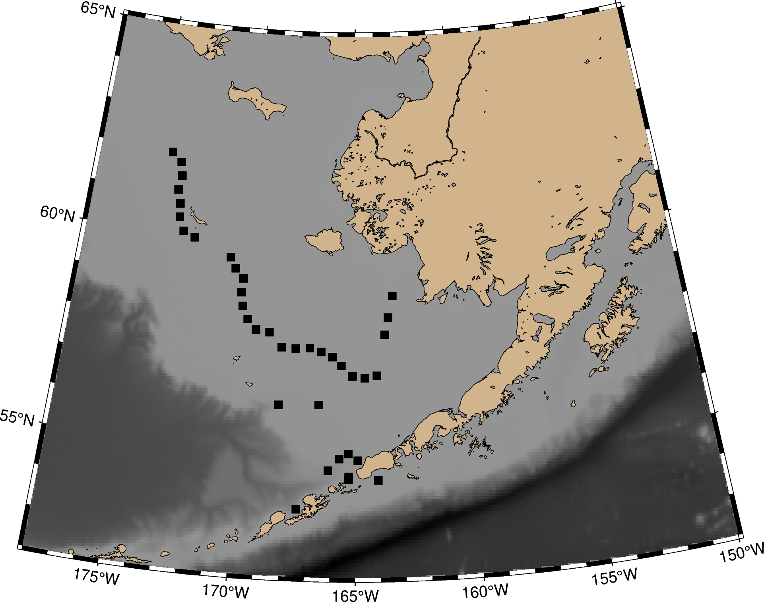

a)

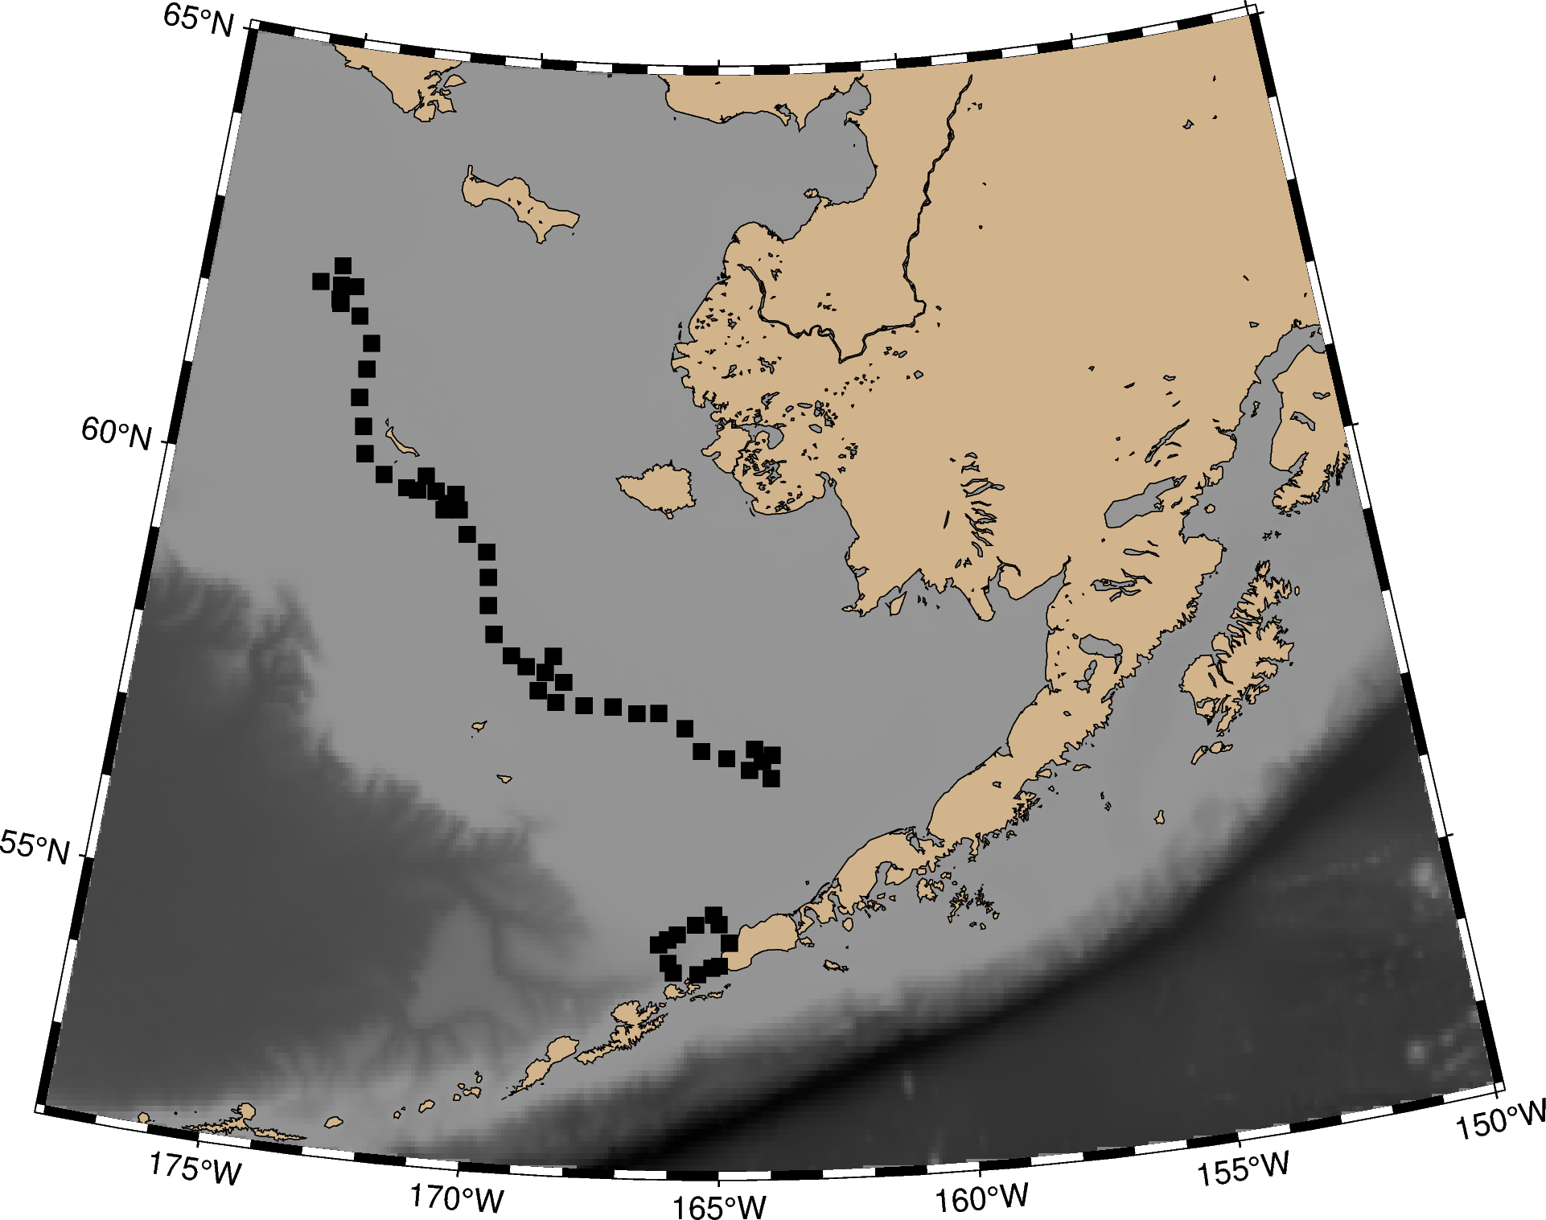

b)

c)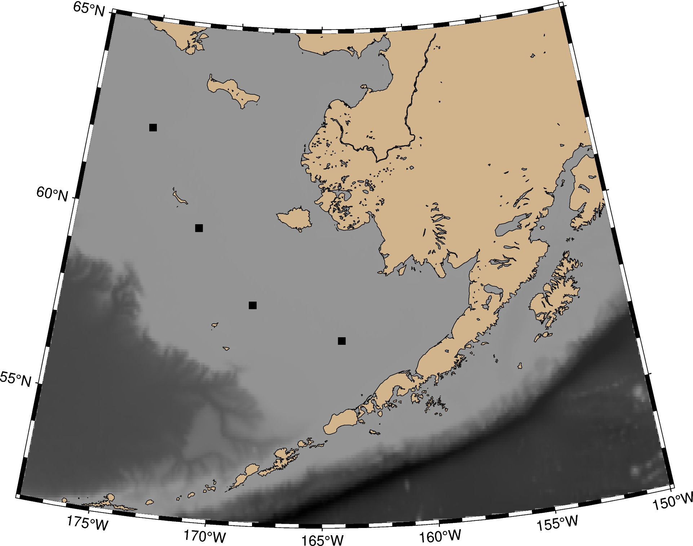

4. Mooring Recovery/Deployment Sites 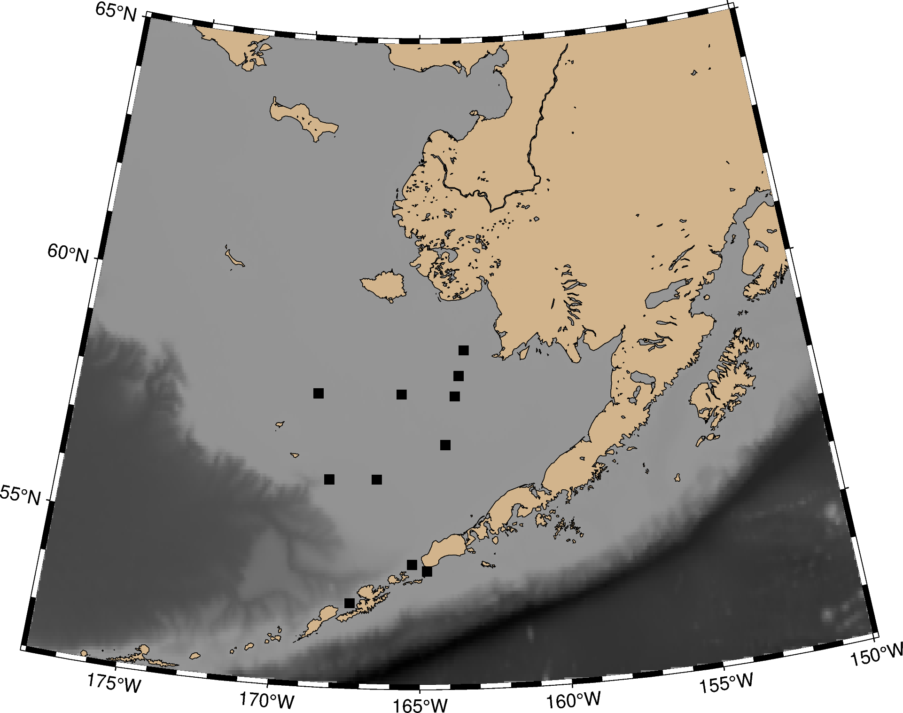

5. Potential Pop Up Mooring deployment sites.

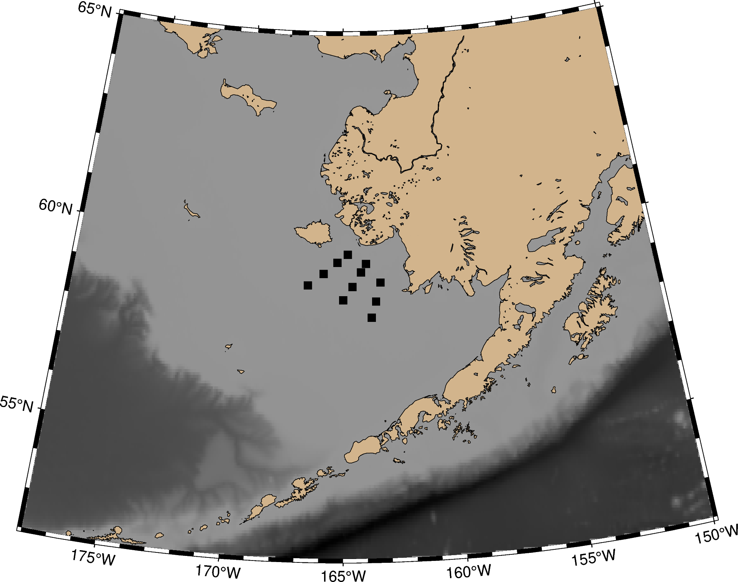

6. Glider Deployment Location

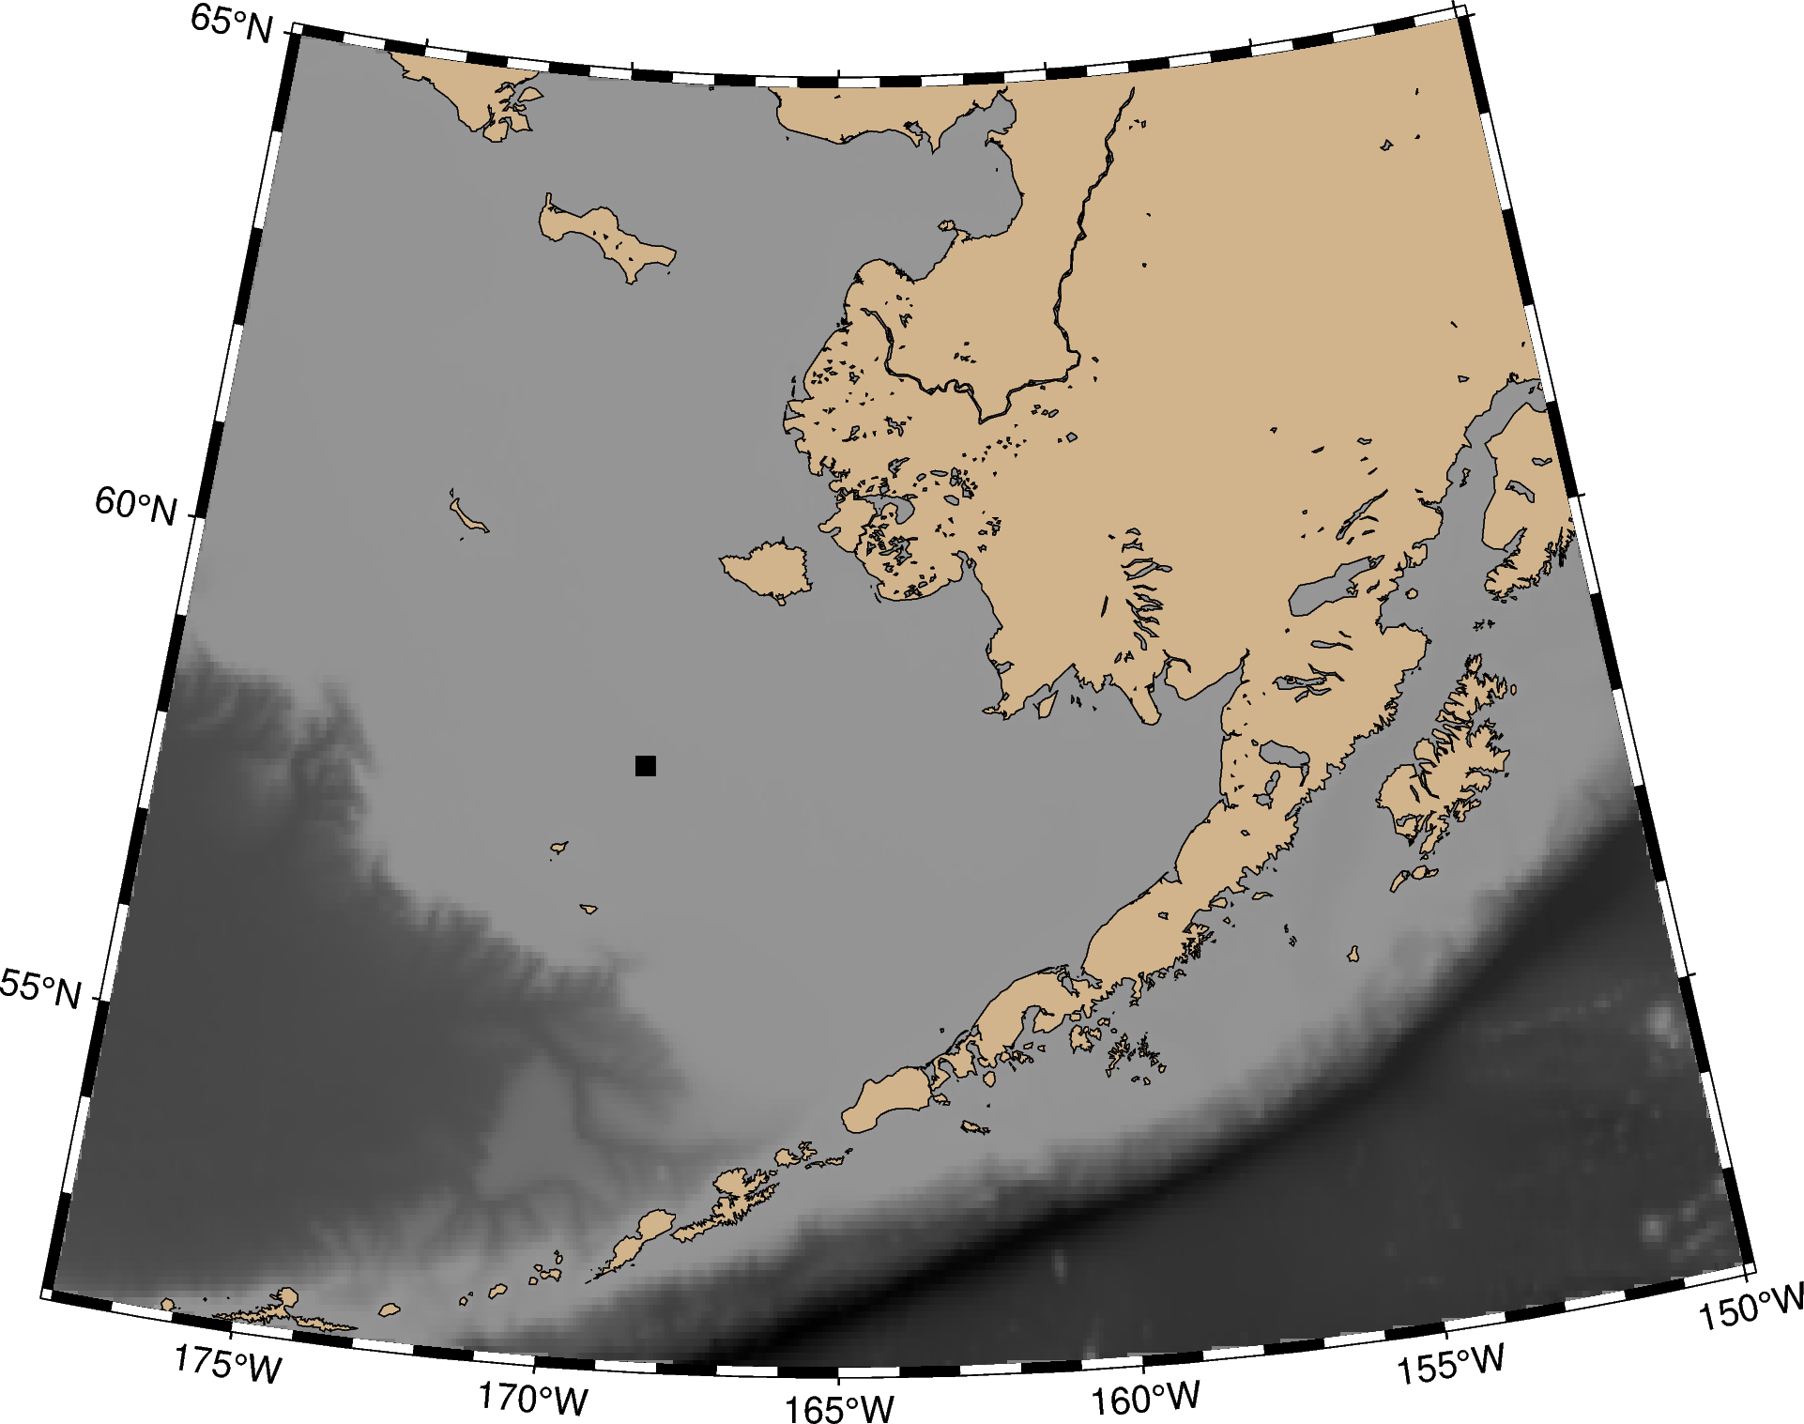

**Appendix II: Mooring Diagrams**

**23BSP-2A**

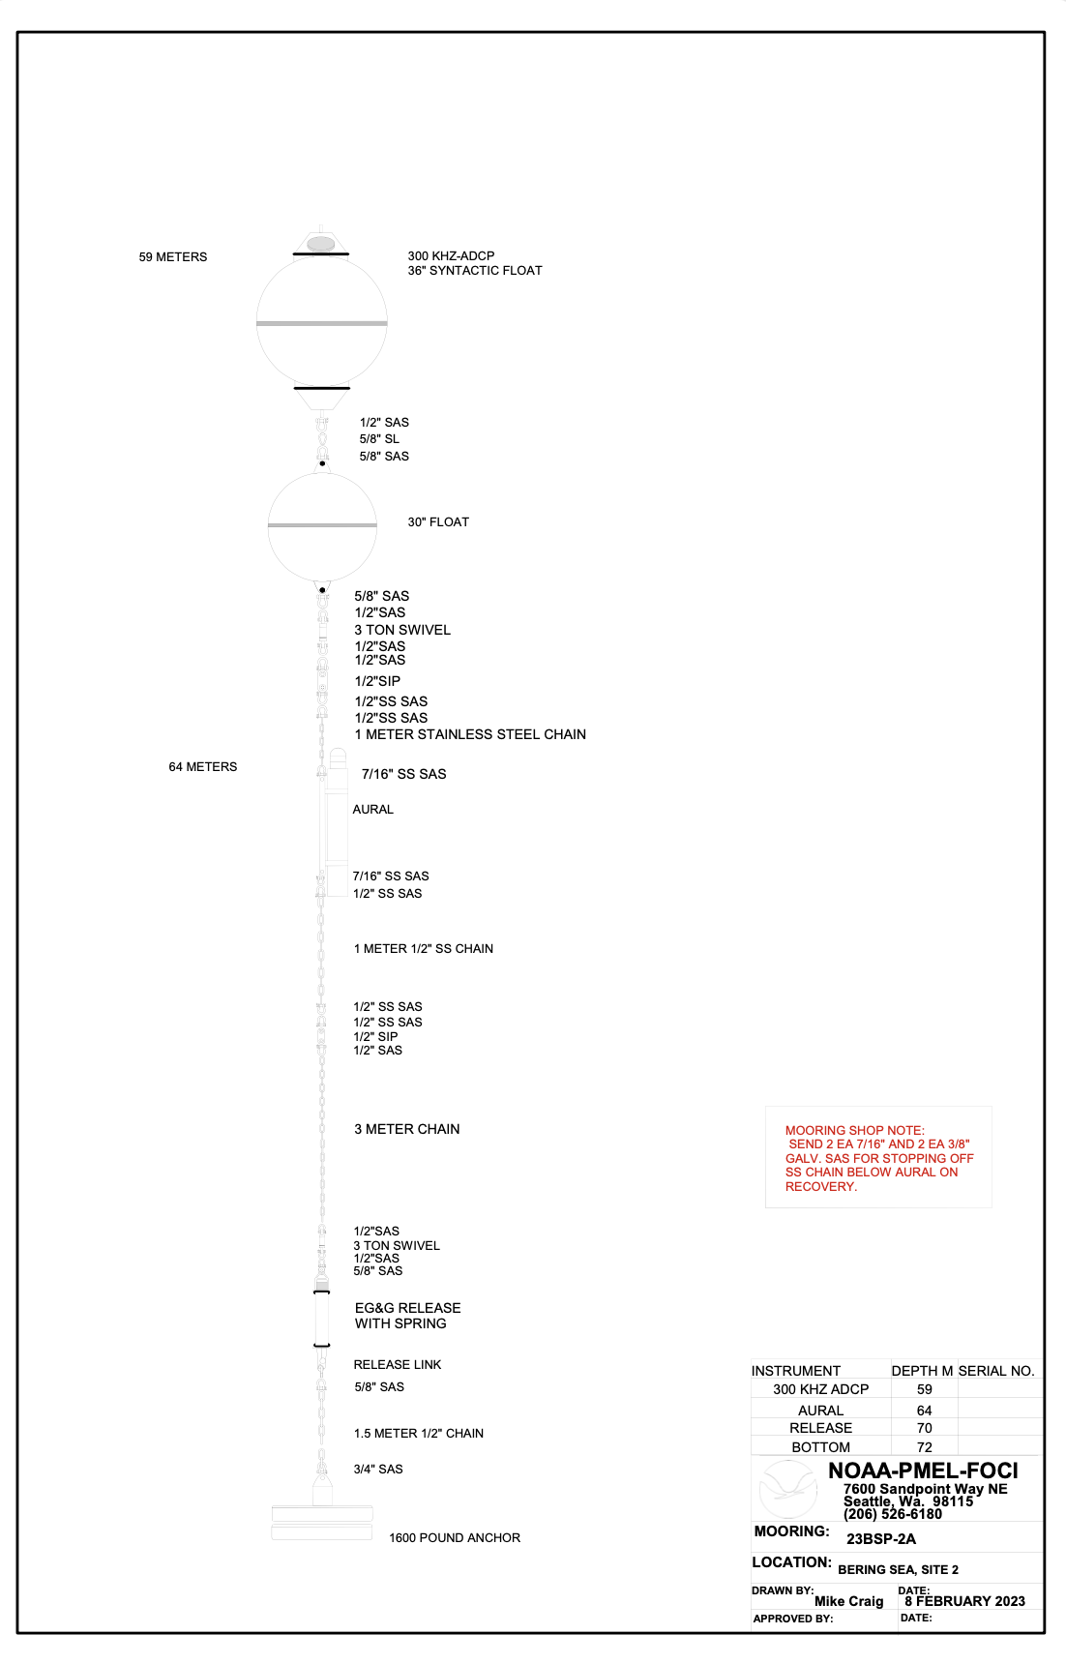

**23BS-2A**

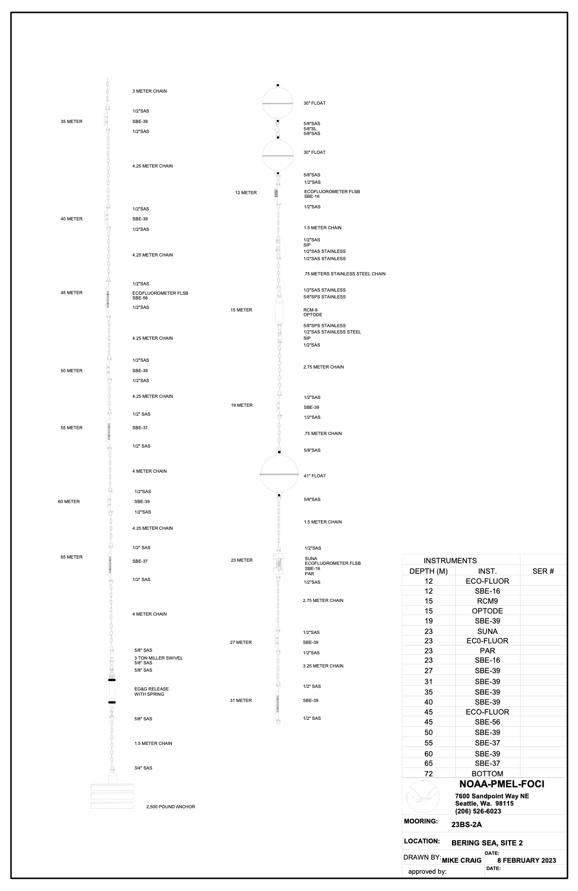

**23BSPR-2A**

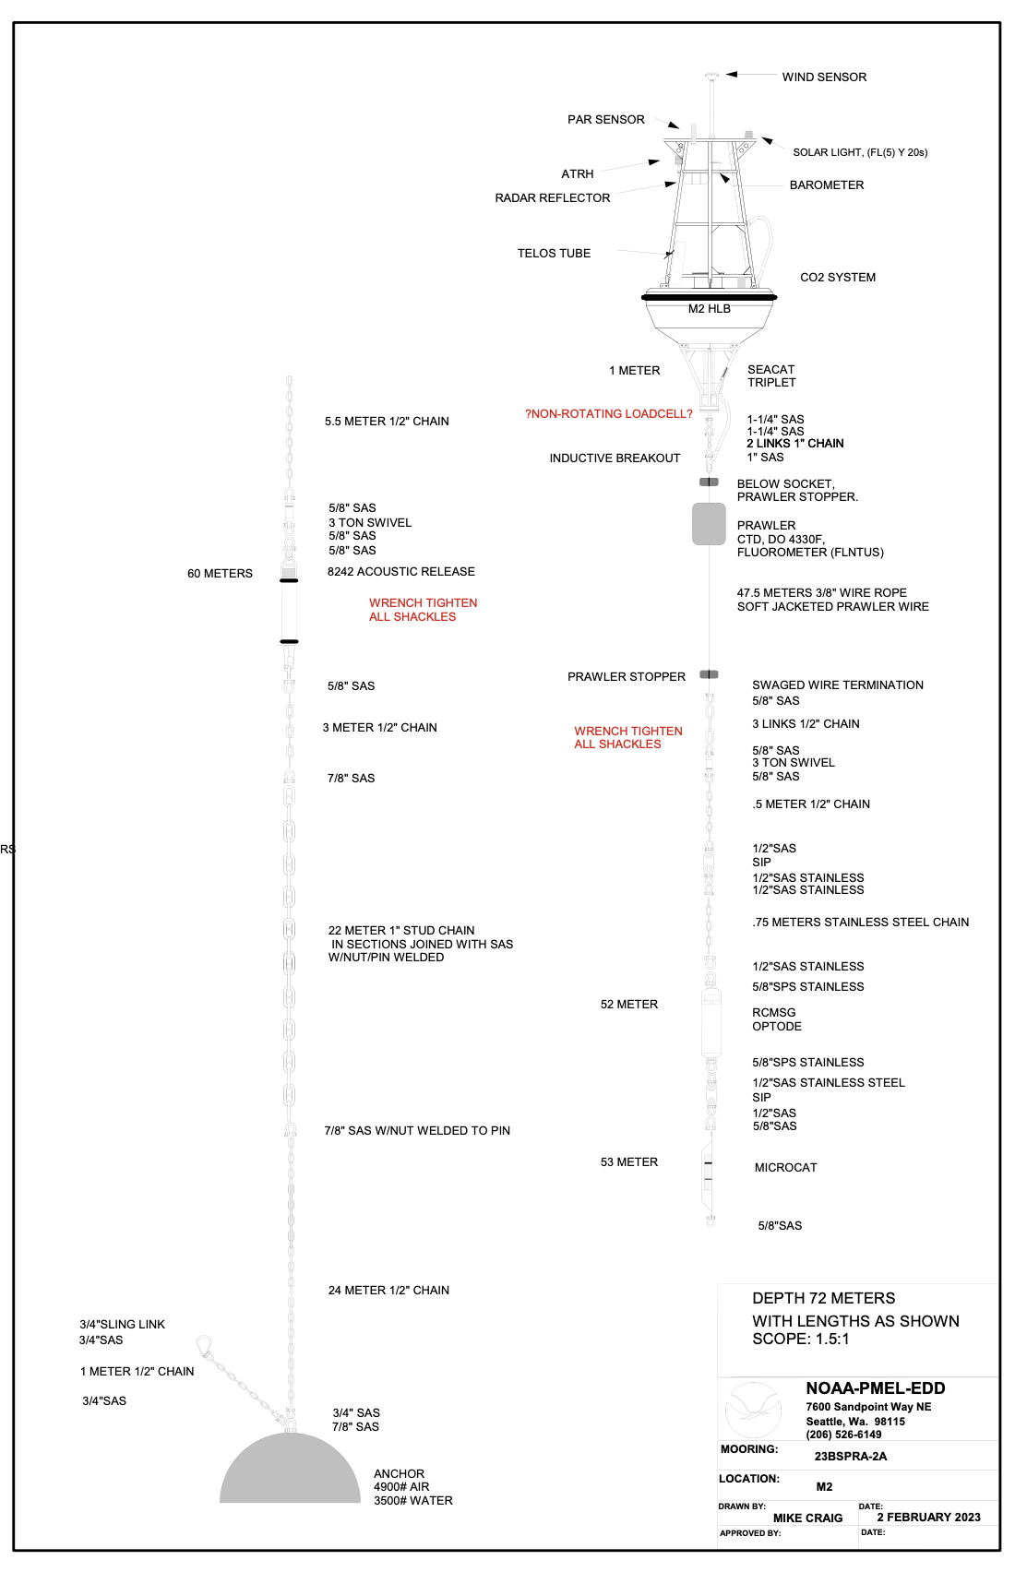

**23BSV-2A**

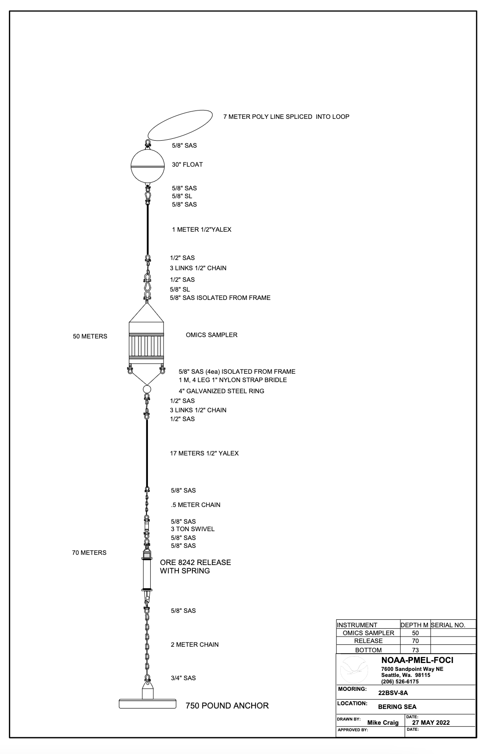

**23BS-4A**

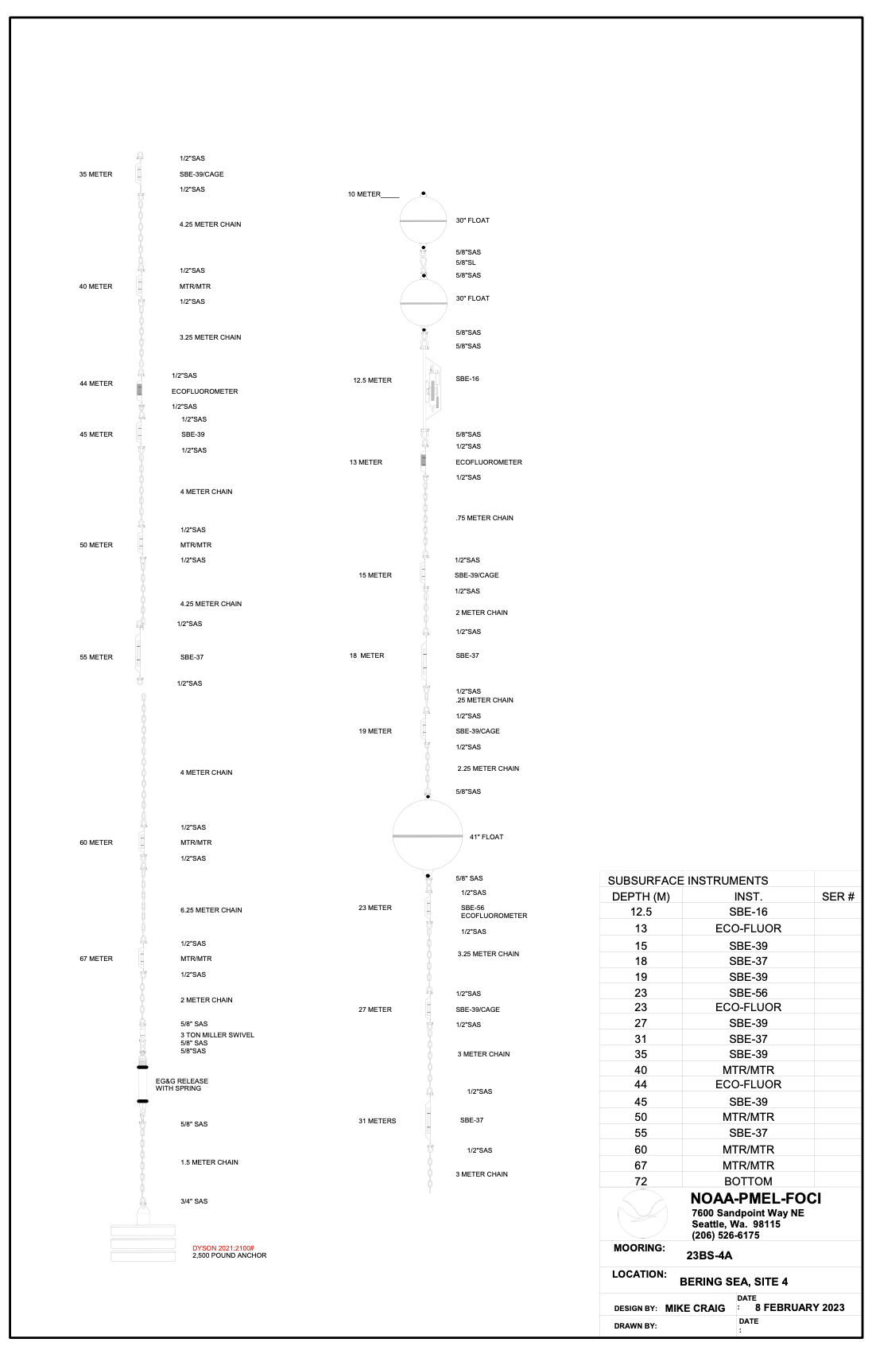

**23BSP-4A**

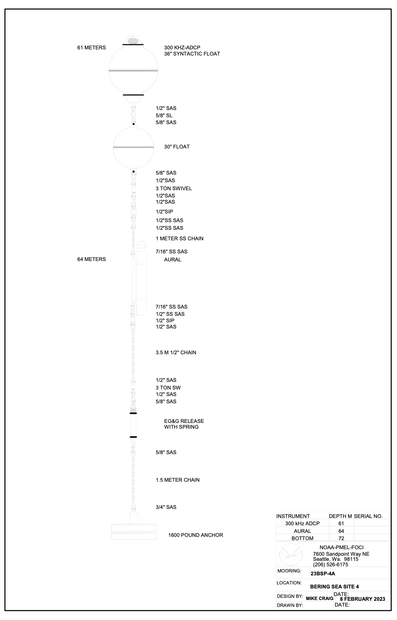

**23KUM-1A**

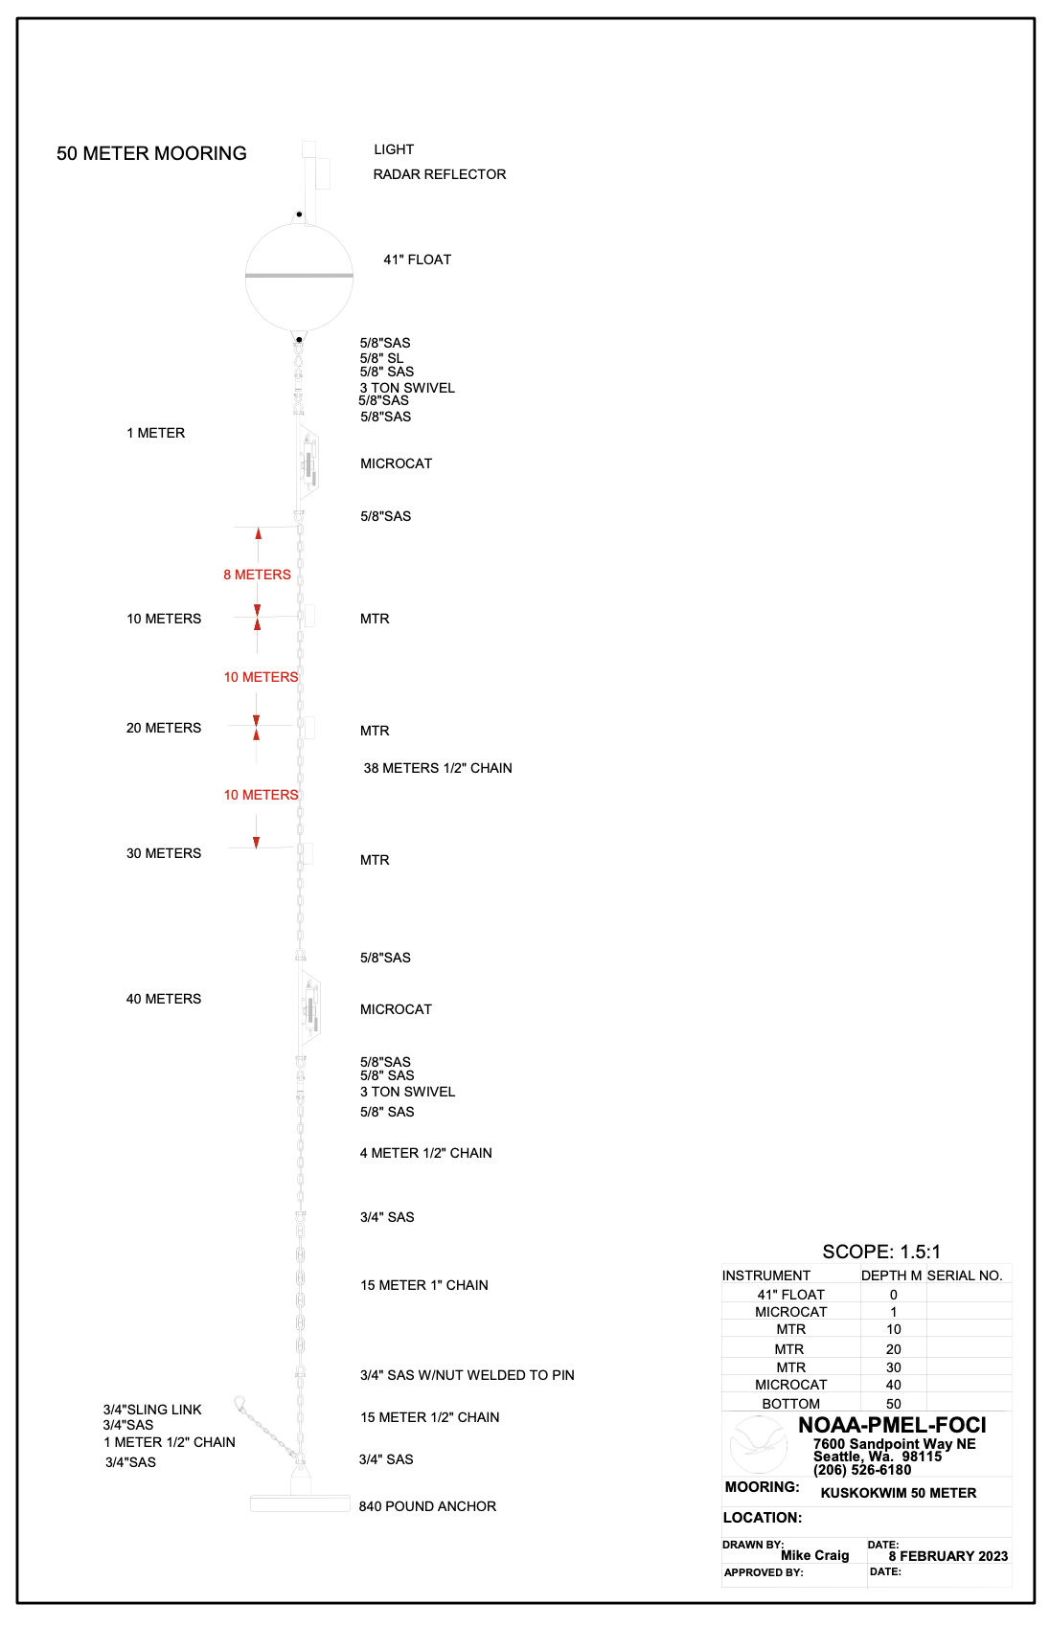

**23KUM-2A**

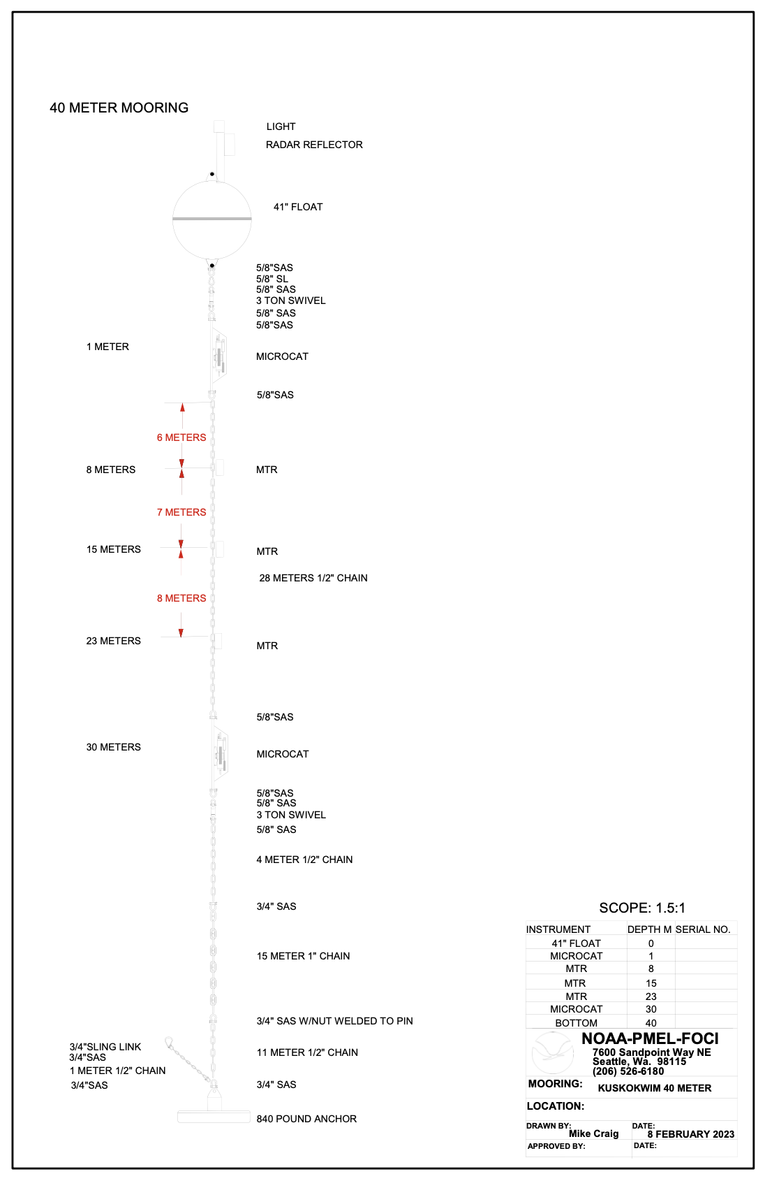

**23KUM-3A**

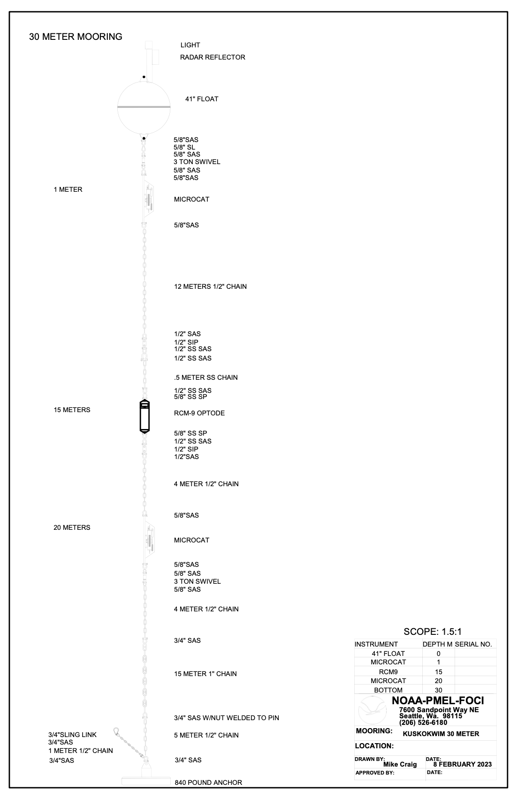

**23UPP-3A**

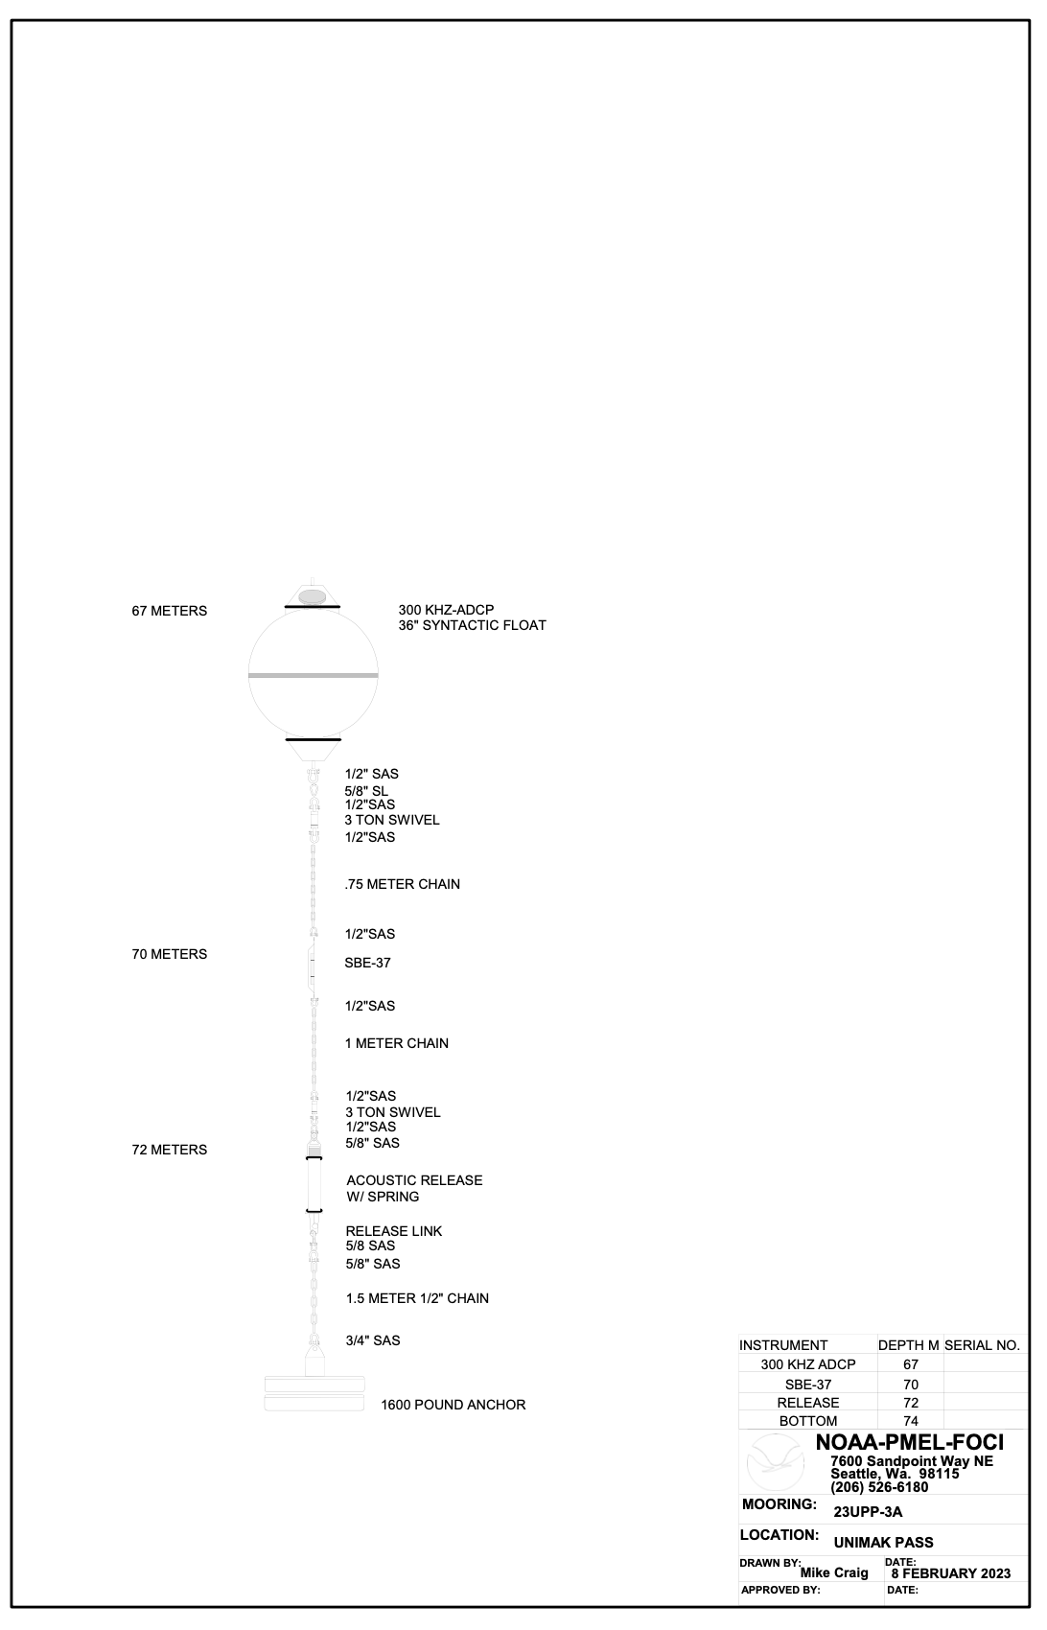

**22KUITAEPR-4A**

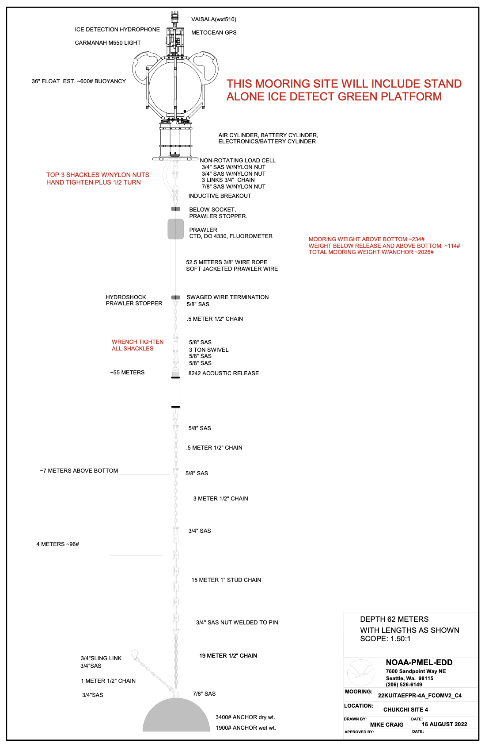

**22BSP-2A**

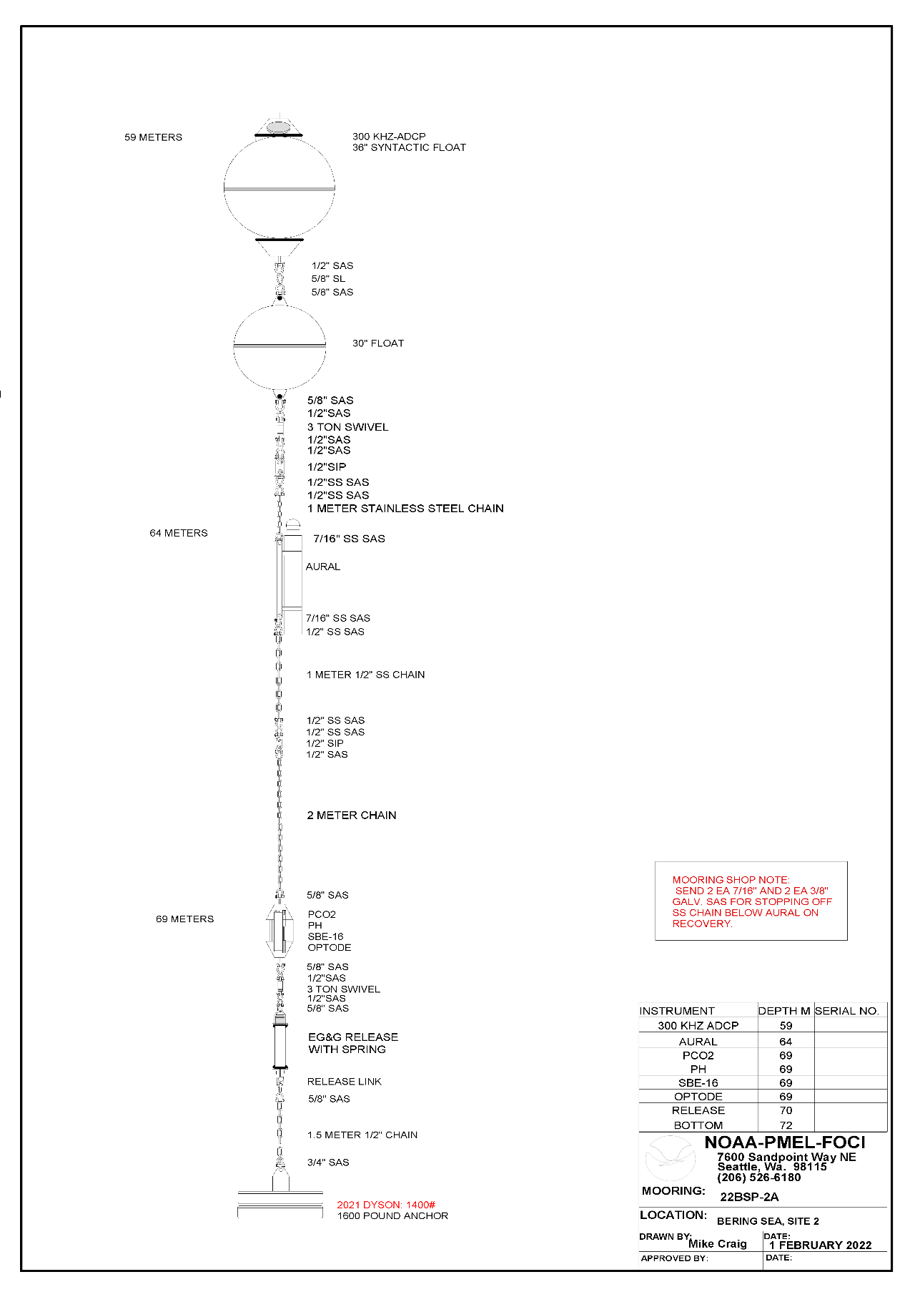

**22BS-4A**

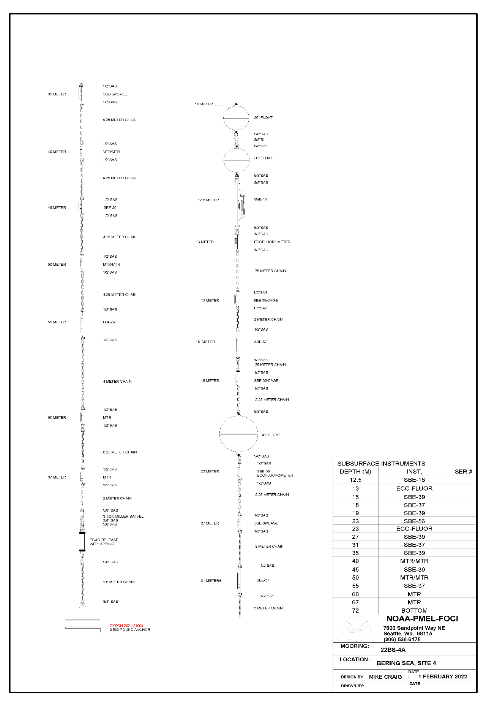

**22BSP-4A**

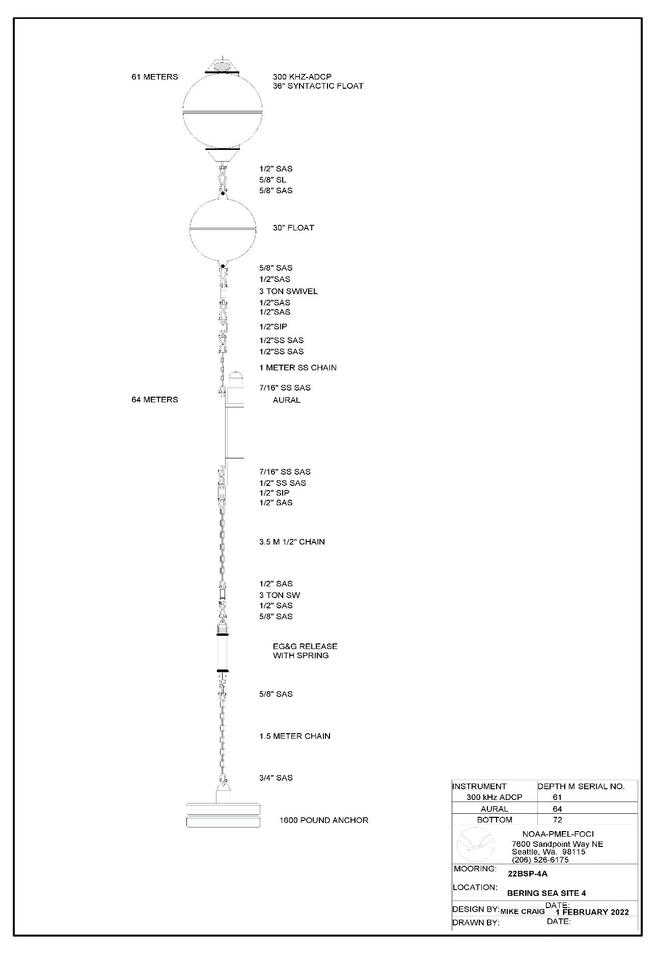

**22UPP-3A**

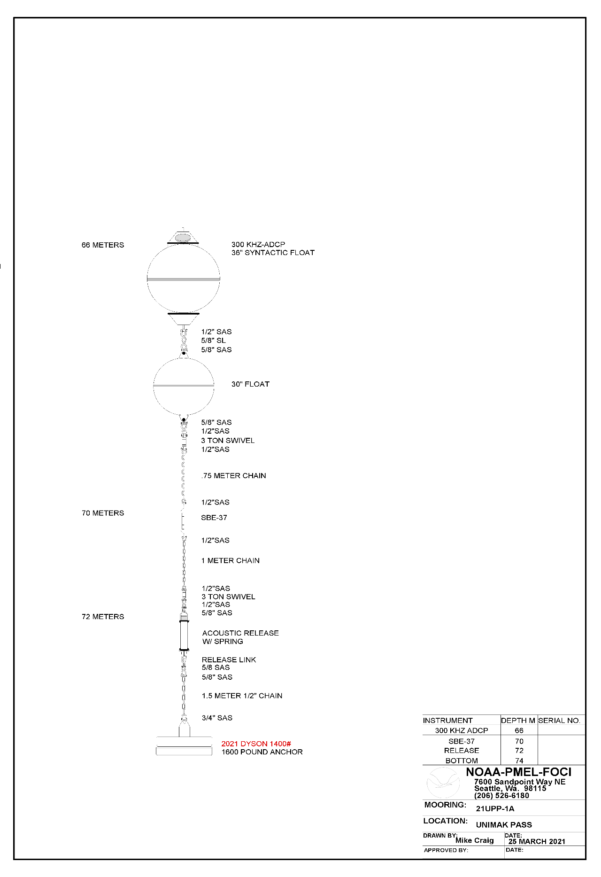

**Marine Mammal Mooring**

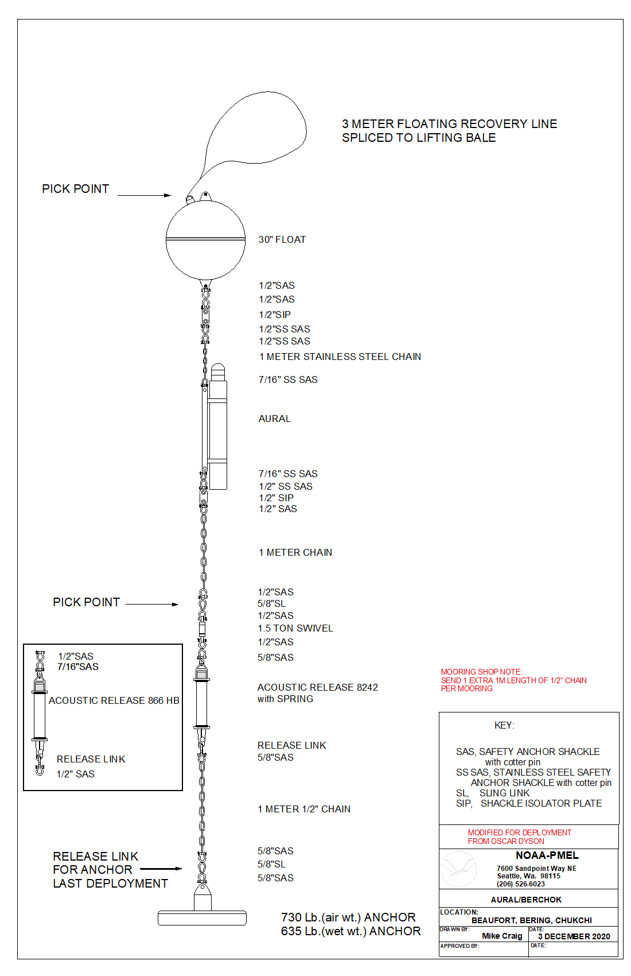

**Appendix III: Chemical Hygiene Plan**

Previous sections of the Project Instructions include a list of hazardous materials by name and anticipated quantity. Chemicals will be transported, stored and used in a manner that will avoid any spills and adequate containment, absorbents and cleanup materials will be available in the event of a chemical spill.

The scientific chemicals to be used for this project are: (1) ethyl alcohol (100%) and (2) formaldehyde (37%) and reagent chemicals for the preservation and analysis of oxygen samples. Other chemicals brought aboard are consumer products in consumer quantities. Dilutions of the scientific chemicals will be used to preserve *in faunal* organisms collected with towed zooplankton nets (bongos and CalVETs) as described in the Operations section of these Project Instructions and for the pickling and analysis of oxygen samples for calibration of the oxygen sensors on the CTD. Use of these chemicals and the specified dilutions will only occur in exterior locations on the ship away from air intakes. Scientific chemicals shall not be disposed over the side.

Standard Operating Procedures and Information Sheets are provided here for the scientific chemicals. Included are details concerning personal protective equipment, work area precautions, special handling and storage requirements, spill and accident procedures/first aid, waste disposal and other pertinent information. Both small and large spills are of particular concern; in both cases, the spill response is intended to first contain the spill and then neutralize it. This may be easily accomplished for small spills depending on the degree of vessel motion and the prevailing environmental conditions. In all cases, the first responder should quickly evaluate the risks of personal exposure versus the potential impacts of a delayed response to the spill and act accordingly. For example, if the spill is small and it is safe to do so, a neutralizing agent should be rapidly applied to encircle/contain the spill and then cover it. However, a large formaldehyde spill (> 1 L) is extremely hazardous and individuals at risk of exposure should immediately leave the area. The CO or OOD should be notified immediately so that a response team with self-contained breathing apparatus (SCBA) can be deployed to complete the cleanup operation or dispense the hazard with a fire hose directed overboard. The vessel’s course should be adjusted to minimize exposure of personnel to wind-driven vapors and to limit spread of the spill due to vessel motion.The reportable quantity (RQ) of formaldehyde is 1,000 pounds and the RQ for ethyl alcohol is 5,000 pounds which greatly exceed the quantities brought aboard for this project.

**Standard Operating Procedures – Formaldehyde At-Sea**











Chemical Name: 37% Formaldehyde

UN Number: 1198

Hazard Ratings: (on a scale of 0 to 4)

Health (blue): 3 Flammability (red): 2

Reactivity (yellow): 2 Special (white):

Personal Protection Gear Needed

*gloves

*goggles or face shield

Special Handling Instructions

* If a ventilation hood is not available, then pouring of chemical must be done outside. At least two people should be involved with large chemical transfers in case of an emergency.

* Chemical must be stored at temperatures above 15o c to prevent polymerization of paraformaldehyde.

First Aid

* If swallowed, give large amounts of drinking water and induce vomiting.

*If vapors inhaled, get out into fresh air immediately. Give oxygen if breathing is difficult.

* If spilled on skin or splashed in eyes, flush with water for at least 15 minutes.

Spill Cleanup Procedures

**For small spills** (500-1000 ml):

Cover spill quickly with a Fan Pad and spray on Formalex to deactivate and absorb chemical. Let material sit for 10 - 15 minutes. Dispose of materials in plastic bag.

**For large spills** (>1000 ml):

Use a combination of Fan Pads and Formalex as quickly as possible to contain spill and deactivate it. Vacate area and try to ventilate room, if possible. Call Bridge immediately (x101).

Deactivation/Disposal Procedures at Sea

*Formalex is a greenish liquid that is to be used to insure proper chemical deactivation. Formalex should also be used in conjunction with Fan Pads. Place used Fan Pad in plastic bag, seal, and put in bottom of Spill Kit.

*Fan Pads may be used to absorb small spills alone but these pads work best when used with Formalex to immediately control the vapor layer.

Shipping Procedures and Restrictions

37% formaldehyde cannot be ship by air due to its flammability rating.

All quantities should be over-packed with absorbency material in case the original container is damaged. When shipping by barge or land, labels are not required for quantities under 110 gallons by D.O.T. but the container should have MSDSs and the UN number readily available.

**Standard Operating Procedures – Ethanol At-Sea**











Chemical Name: 100% Alcohol

UN Number: 1170

Hazard Ratings: (on a scale of 0 to 4)

Health (blue): 2 Flammability (red): 3

Reactivity (yellow): 1 Special (white):

Personal Protection Gear Needed

*gloves

*goggles or face shield when pouring

Special Handling Instructions

* Keep away from heat, flame, and other potential ignition sources.

* Store in a well-ventilated area or in a flammable cabinet.

First Aid

* If swallowed, give large amounts of drinking water and induce vomiting.

* If vapors inhaled, get out into fresh air immediately. Give oxygen if breathing is difficult.

* If spilled on skin or splashed in eyes, flush with water for at least 15 minutes.

Spill Cleanup Procedures

Absorb ethanol with 3M Sorbent Pads and allow to dry in a well-ventilated area away from ignition source.

Deactivation/Disposal Procedures at Sea

Use 3M Sorbent Pads to absorb the ethanol. Put used pads outside to dry (secure from blowing overboard and exposure to flame). Once dry, the pads may be reused or burned.

Shipping Procedures and Restrictions

Due to the flammability rating of 95% ethanol, this chemical cannot be shipped by air. Transportation by barge or land vehicle will require the ethanol container to be over-packed with absorbent materials such as clumping kitty litter or shredded paper. Include MSDS and the UN number with the shipment for reference in the event of a spill.

**Appendix IV: Table with Estimated Weights.**

| **Mooring Name** | **Anchor Wt.** | **Chain Wt.** | **Instrument Wt.** | **Releases** | **Floats** | **Total Wt.** |
| --- | --- | --- | --- | --- | --- | --- |
| 23UPP | 1600 | 100 | 100 | 112 | 400 | 2312** |
| 23BS2 | 2500 | 450 | 600 | 112 | 700 | 4362 |
| 23BSP2 | 1600 | 100 | 675 | 112 | 550 | 3037 |
| 23BSPR2 | 3500 | 1500 | 350 | 112 | 2500 | 9362 |
| 23BSV2 (eDNA) | 800 | 100 | 200 | 112 | 400 | 1612 |
| 23BSP4 |  |  | Likely not to | be loaded | due to weight |  |
| 23BS4 |  |  | Likely not to | be loaded | due to weight |  |
| 23KUM1A | 800 |  | 50 | – | 400 | 1250 |
| 23KUM2A | 800 |  | 75 | – | 400 | 1275 |
| 23KUM3A | 800 |  | 50 | – | 400 | 1250 |
| 23KUP1A | 1600 |  | 50 | – | 400 | 2050 |
| 23KUP2A | 1600 |  | Likely not to | be loaded | due to weight |  |
| MML UN01 | 850 | 67 | 175 | 112 | 165 | 1369 |
| MML PC01 | 850 | 67 | 175 | 112 | 165 | 1369 |
| MML BS10 | 850 | 67 | 175 | 112 | 165 | 1369 |
| MML UM01 | 850 | 67 | 175 | 112 | using recovered | 1204 |
| Other Equipment |  |  |  |  |  |  |
| dragging Hooks |  |  |  |  |  | 200 |
| CO2 Equip |  |  |  |  |  | 1200 |
| Mooring gear |  |  |  |  |  | 3600 |
| tires |  |  |  |  |  | 200 |
| Misc. Equip. |  |  |  |  |  |  |
| Lab Equip |  |  |  |  |  | 500 |
| MML gear tote |  |  |  |  |  | 400 |
| sonobuoys (36) |  |  |  |  |  | 1000 |
| Popups (2) |  |  |  |  |  | 200 |
| AFSC Totes/Gear |  |  |  |  |  | 3900 |
| Oculus |  |  |  |  |  | 500 |
|  |  |  |  | Final Estimated Weight* |  | TBD |

*Final weight to be provided to the Captain before loading, not to exceed 38,000 pounds.

**UPP may be shipped to Dutch to be deployed on follow-on cruise and is not in final weight